Swimming Pool Questionnaire
Q1 Please select all of the following that apply to you:
- I do not go outside at night/dusk (go to question 4)
- I have never observed bats flying around my property (go to question 4)
- I have observed bats flying around my property/backyard
- I have observed bats flying over my swimming pool
- I have observed bats swooping down to drink from my swimming pool
- I have had bats fall into my swimming pool

Q2 Please indicate the frequency you have observed bats around your pool:
- Nightly
- 2-3 times per week
- 2-3 times per month
- Occasionally within the year

Q3 Which months have you noticed bats in your backyard (check all that apply):
- January | - July
- February | - August
- March | - September
- April | - October
- May | - November
- June | - December

Question 4-7, Pool
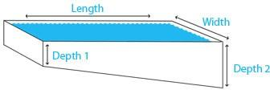

Q4 From the photo of the pool please indicate, in feet, the length of your pool
________________________________________________________________

Q5 From the photo of the pool please indicate, in feet, the width of your pool
________________________________________________________________

Q6 From the photo of the pool please indicate, in feet, the shallow end (Depth 1) of your pool
________________________________________________________________

Q7 From the photo of the pool please indicate, in feet, the deep end (Depth 2) of your pool
________________________________________________________________

Pool Types
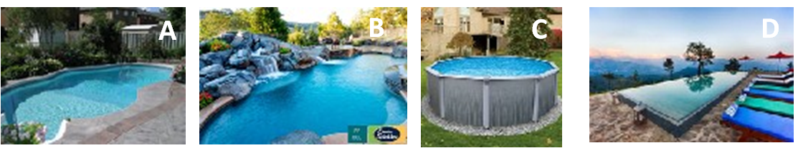

Q8 Please select all that apply to your pool, based on the photo above:
- In ground pool (depicted in photo A)
- Pool has raised wall/cliff features (depicted in photo B)
- Pool is above ground (depicted in photo C)
- Infinity pool (depicted in photo D)

Q9 What color is your pool interior?
________________________________________________________________

Pool Texture
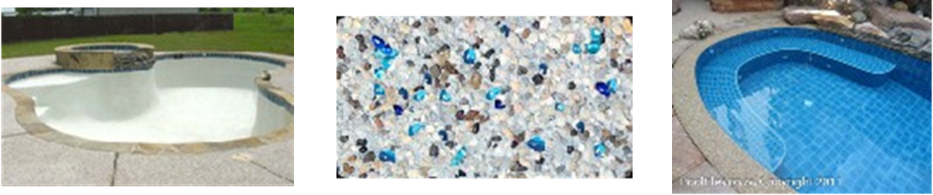

Q10 Please select any of the following that apply to the interior finish of your pool:
- Plaster
- Aggregate
- Tile
- Other

Q11 If you choose "other" for the interior finish of your pool please explain:
________________________________________________________________

Q12 Pool shape:
- Circular/Curvy
- Square/Rectangular
- Other

Q13 If "other" for pool shape please explain:
________________________________________________________________
________________________________________________________________
________________________________________________________________

Q14 Is your pool temperature controlled?
- Yes
- No (go to question 16)

Q15 If yes, please indicate the temperature at which your pool is maintained and if it changes seasonally:
________________________________________________________________
________________________________________________________________
________________________________________________________________

Q16 Does your pool have a connected hot tub?
- Yes
- No (go to question 18)

Q17 If yes, does the water from the hot tub flow into the main pool?
- Yes
- No

Q18 Does your pool have a fountain or waterfall feature?
- Yes
- No (go to question 22)

Q19 Please select all that applies about when your fountain/waterfall features are turned on:
- Year round
- Certain months during the year
- Sporadically
- Rarely

Q20 If your fountain/waterfall feature is only turned on during certain months, please check all that apply:
- January | - July
- February | - August
- March | - September
- April | - October
- May | - November
- June | - December

Q21 If your fountain/waterfall feature is only on certain times between dusk and dawn please describe:
________________________________________________________________
________________________________________________________________
________________________________________________________________
________________________________________________________________

Q22 Does your pool have underwater lights?
- Yes
- No (go to question 26)

Q23 If yes, please select all that apply to your underwater pool lights:
- Remain on overnight
- Are on a daily timer system
- Remain on year round
- Remain on seasonally
- Sporadically/only on certain occasions
- Only when pool is in use

Q24 If your underwater pool lights are on a daily timer or sporadically on please describe:
________________________________________________________________
________________________________________________________________
Q25 Please indicate the months when you use your underwater pool lights between dusk and dawn (select all that apply):
- January | - July
- February | - August
- March | - September
- April | - October
- May | - November
- June | - December

Q26 Does your pool have a cover?
- Yes
- No (go to question 28)

Q27 Please indicate the months when your pool is typically covered (select all that apply):
- January | - July
- February | - August
- March | - September
- April | - October
- May | - November
- June | - December

Pool netting/cover (Questions 28-31)
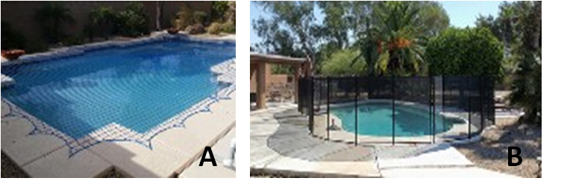

Q28 Does your pool have safety netting over it (depicted in photo A)?
- Yes
- No (Go to question 30)

Q29 Is this netting on permanently or do you only have it on during certain times (please describe):
________________________________________________________________
________________________________________________________________

Q30 Does your pool have a fence around it (depicted in photo B)?
- Yes
- No (Go to question 32)

Q31 Is the fence permanent? If not please explain:
________________________________________________________________
________________________________________________________________
________________________________________________________________

Q32 What type of water treatment do you utilize for your pool?
- Chlorine
- Bromine
- Salt
- Mineral
- Ionized
- Other

Q33 If "other" for type of water treatment please describe:
________________________________________________________________
________________________________________________________________
________________________________________________________________

Q34 How often is your pool treated?
________________________________________________________________

Q35 How often is your pool's water quality tested?
- 2-3 days per week
- Weekly
- Sporadically
- Rarely

Q36 Is your pool filtration system on a timer?
- Yes
- No (go to question 38)

Q37 Is your filtration system turned on between dusk and dawn (describe days and times):
________________________________________________________________
________________________________________________________________
________________________________________________________________

Q38 How often are leaves and debris skimmed manually from the surface of your pool?
- Daily
- 2-3 days per week
- Weekly
- Sporadically
- Rarely

Q39 Does your pool have a vacuum?
- Yes
- No (go to question 41)

Q40 Please indicate the time(s) your vacuum is programmed to run between dusk and dawn:
________________________________________________________________
________________________________________________________________
________________________________________________________________

Q41 Do you employ a pool cleaning/maintenance service?
- Yes
- No (go to question 44)

Q42 How frequently does the pool cleaning company service your pool?
- Multiple times per week
- Weekly
- Monthly
- Seasonally
- Other

Q43 If "other", please describe the frequency of the pool cleaning company:
________________________________________________________________
________________________________________________________________
________________________________________________________________

Q44 Do you have an AC unit located near the pool?
- Yes
- No

Q45 Do you have outdoor speakers/sound system in your backyard?
- Yes
- No (go to question 47)

Q46 If yes, how often (nights per week) do you play music between dusk and dawn?
________________________________________________________________
________________________________________________________________
________________________________________________________________
Q47 Do you have a sprinkler system in your backyard?
- Yes
- No (go to question 49)

Q48 If yes, please describe your sprinkler system's schedule (days/times) of use:
________________________________________________________________
________________________________________________________________

Q49 Is your backyard floodlit?
- Yes
- No (go to question 57)

Q50 Does your backyard flood light illuminate your pool?
- Yes
- No

Q51 If yes, please select all that apply to your backyard floodlights:
- Remain on overnight
- Set on daily timers
- Are on motion sensors

Q52 If your backyard flood lights are on timers, please indicate all that apply to the times which they are turned on and off:
- 6 PM | - 12 AM
- 7 PM | - 1 AM
- 8 PM | - 2 AM
- 9 PM | - 3 AM
- 10 PM | - 4 AM
- 11 PM | - 5 AM

Q53 If your backyard flood lights are on seasonally, select months you would have them turned on:
- January | - July
- February | - August
- March | - September
- April | - October
- May | - November
- June | - December

Q54 What type of light bulb is used in your backyard flood lighting?
- LED
- Incandescent
- Gas lit/flame
- Other

Q55 If "other" for types of light bulbs used in your backyard flood lighting please describe:
________________________________________________________________
________________________________________________________________
________________________________________________________________

Q56 What is the wattage of your backyard flood lights?
________________________________________________________________

Q57 Do you have backyard lights (not flood lights)?
- Yes
- No (go to question 65)

Q58 Do your backyard lights illuminate the pool?
- Yes
- No

Q59 Please select all that applies to your backyard lights:
- Remain on overnight
- Set on daily timers
- Are used year-round
- Are used seasonally
- Are on motion sensors

Q60 If your backyard lights are on timers, please indicate all that apply to the times which they are set to turn on and off:
- 6 PM | - 12 AM
- 7 PM | - 1 AM
- 8 PM | - 2 AM
- 9 PM | - 3 AM
- 10 PM | - 4 AM
- 11 PM | - 5 AM
Q61 If your backyard's lights are used seasonally, please indicate the months which they would be turned on (select all that apply):
- January | - July
- February | - August
- March | - September
- April | - October
- May | - November
- June | - December

Q62 What type of light bulb is used in your backyard lighting?
- LED
- Incandescent
- Gas lit/flame
- Other

Q63 If "other" for type of light bulb used please explain:
________________________________________________________________
________________________________________________________________
________________________________________________________________

Q64 What is the wattage of your backyard lights?
________________________________________________________________
________________________________________________________________
________________________________________________________________

Q65 Do you have bushes/shrubs within 5ft of your swimming pool?
- Yes
- No (go to question 69)

Q66 If yes, how tall (in ft.), are your bushes/shrubs?
________________________________________________________________

Q67 If bushes border your pool, how many sides are bordered?
- 1
- 2
- 3
- 4

Q68 If your pool is a circle, oval, or other please indicate the percentage of bushes/shrubs that surround the border of your pool?
________________________________________________________________

Q69 Can you see any tall trees from your pool?
- Yes
- No (go to question 74)

Q70 If yes, how many tall trees can you see from your pool?
________________________________________________________________

Q71 If yes, how far away, in feet, is the closest tree from your pool (inside or outside your backyard)?
________________________________________________________________

Q72 If yes, is your closest tree isolated or near other trees?
________________________________________________________________

Q73 If multiple trees are present, describe the tree canopies (treetops):
- Overlapping
- Touching
- Almost touching
- Close (between 1 ft and 5 ft)
- >5 ft apart

Q74 Is your pool ever closed during the year?
- Yes
- No (Go to question 76)

Q75 If it does close during the year, select all the months it is closed:
- January | - July
- February | - August
- March | - September
- April | - October
- May | - November
- June | - December

Q76 When the pool is open how often do you use the pool?
- Nightly
- 2-3 times/week
- Weekly
- Sporadically
- Other

Q77 If "other" please indicate how often you use the pool?
________________________________________________________________
________________________________________________________________

Q78 Do you use your pool at dusk/night?
- Yes
- No (Go to question 81)

Q79 If yes, please indicate which option best represents your evening pool use:
- Nightly
- 2-3 times per week
- Weekly
- Sporadically
- Other

Q80 If "other" please describe your evening pool use:
________________________________________________________________
________________________________________________________________
________________________________________________________________

Q81 Are there typically floating objects left in your pool overnight (floaties, toys, swim-mats. etc.)? If yes please describe:
________________________________________________________________
________________________________________________________________

Q82 Do you have dogs/pets that have access to your backyard at night?
- Yes
- No

Q83 If yes, please indicate (all that apply) the hours during which your pet would have access to the backyard:
- 6 PM | - 12 AM
- 7 PM | - 1 AM
- 8 PM | - 2 AM
- 9 PM | - 3 AM
- 10 PM | - 4 AM
- 11 PM | - 5 AM

