Supplementary Materials S1
Site Vegetation Characteristics
The three most common overstory tress in the GTF are cedar elm (Ulmus crassifolia), hackberry (Celtis laevigata), and green ash (Fraxinus pennsylvanica), with cedar elm being the dominant species in relatively drier areas and green ash dominating the wettest. In younger forest habitats, eastern cottonwood (Populus deltoides) and black willow (Salix nigra) are the most common overstory trees. In mature levee forests, where flooding is infrequent, masting trees like burr oak (Quercus macrocarpa), pecan (Carya illinoinensis), and mulberry (Morus rubra) are common. The most common understory plant is eastern swamp privet (Forestiera acuminate), especially in wetter areas, whereas dense stands of the invasive Chinese privet (Ligustrum sinense) dominate the understory in some of the forest’s drier areas.
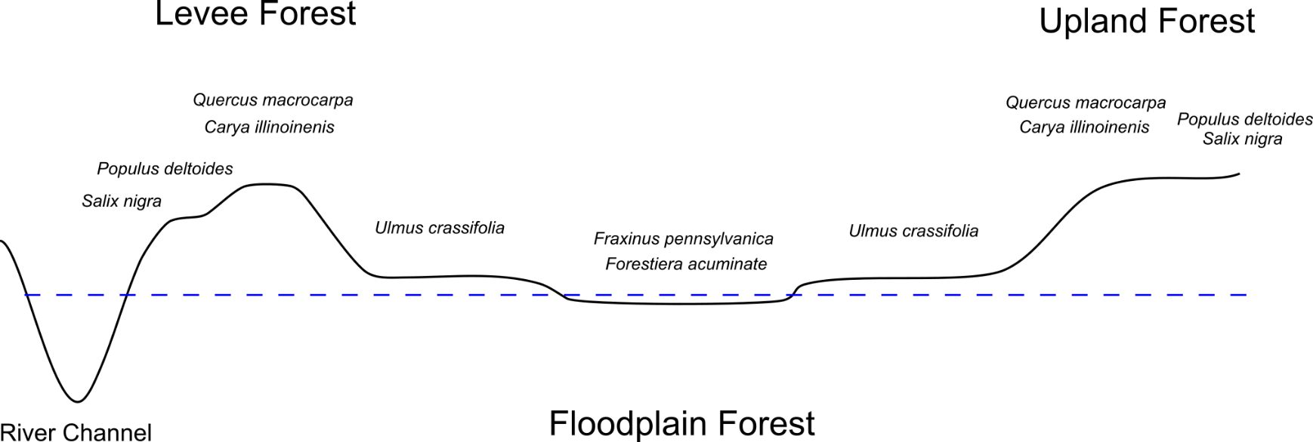
Figure S1. Cross section of habitat types and dominant tree species in the Great Trinity Forest, Dallas, TX. Areas of upland forest are the most likely to contain significant anthropogenic disturbance and early succession grassland or savanna habitat and are often the interface between the GTF and the urban matrix.
LIDAR
We acquired LIDAR data flow over the GTF in 2017 by the North Central Texas Council of Governments in a fixed wing aircraft. The specifications of the LIDAR data are as follows: Leica Specs-AGL LIDAR System, 0.5-meter nominal point spacing, 150 knot aircraft speed, 50-degree field of view, 230.5 kHz pulse rate, 47 Hz scan rate, and 30% average overlap. Multiple returns were recorded for each laser pulse and intensity values were recorded for all returns. Flights occurred during leaf off conditions between January 21 and February 10, 2017. Four Global Navigation Satellite System Base Stations were used in support of the LIDAR missions.
We processed LIDAR data in ArcGIS Pro using the full point cloud data. We developed a digital terrain model (DTM) to normalize all non-ground returns and LIDAR forest structure metrics against. We calculated maximum vegetation height as the average height of first returns. We calculated canopy cover as the number of returns above 4 m divided by the total number of returns. We calculated foliage height diversity using the Shannon Wiener Diversity Index comparing the number of returns in five height classes: 0 to 2 m, 2 to 4 m, 4 to 8 m, 8 to 12 m, and > 12 m.
Drone Imagery and Habitat Types
All drone images were acquired using DJI Phanton 3 Advanced Drone (12 megapixel camera) between October 7th and October 24th 2020. Images were taken at a 90-degree angle from ~ 40m above the canopy. Image acquisition, tree identification and habitat mapping followed a workflow pictured below in Figures S1 and S2.
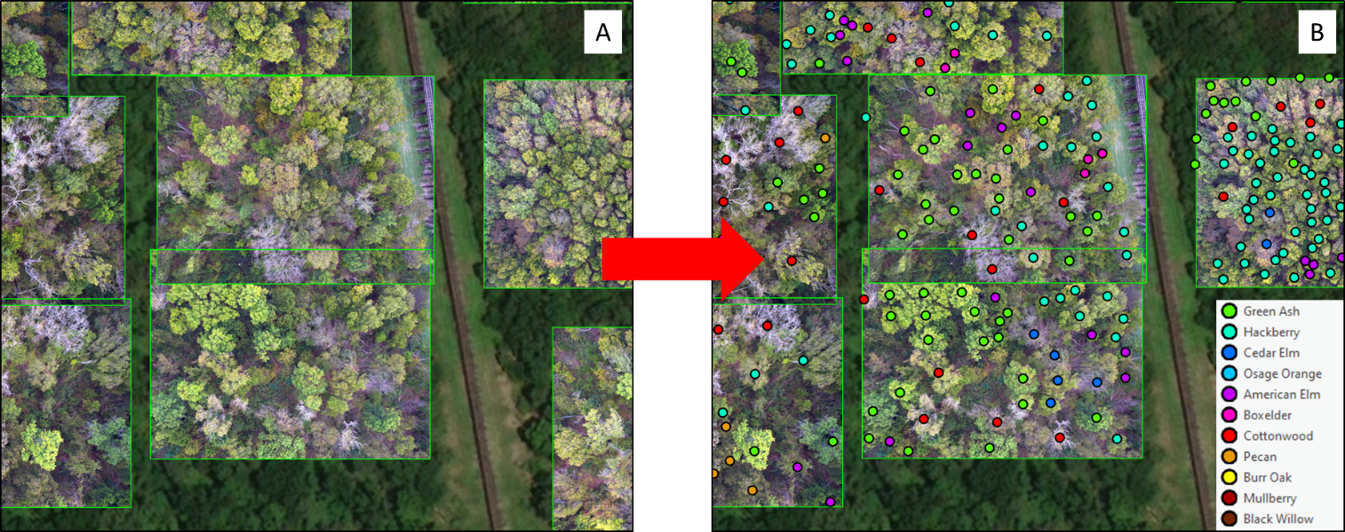
Figure S2 a) Drone images are imported into ArcGIS Pro using the software’s orthomapping tools which creates photogrammetrically correct imagery. b) all individual trees are identified.

We defined our six habitat types by canopy tree composition as follows: 1) climax mixed forest: >90% cedar elm, green ash, and hackberry with none of those individually accounting for >50% of trees; >5% Osage orange; 2) cedar elm forest: >75% cedar elm with Osage orange and hackberry as common minority species; <5% early successional species: American elm (Ulmus americana), boxelder (Acer negundo), eastern cottonwood, and black willow; 3) green ash forest: >75% green ash with hackberry and black willow as common minority types; <10% early successional species: American elm, Boxelder, eastern cottonwood, and black willow; 4) early successional forest: >35% early successional species: American elm, Boxelder, eastern cottonwood, and black willow; 5) levee forest: 10% to 20% masting trees: pecan (Carya illinoinensis), burr oak (Quercus macrocarpa), shumard oak (Quercus shumardii), and mulberry (Morus rubra) which account for the majority of canopy cover because of their large size; and 6) early successional grassland: <50% canopy cover of trees.

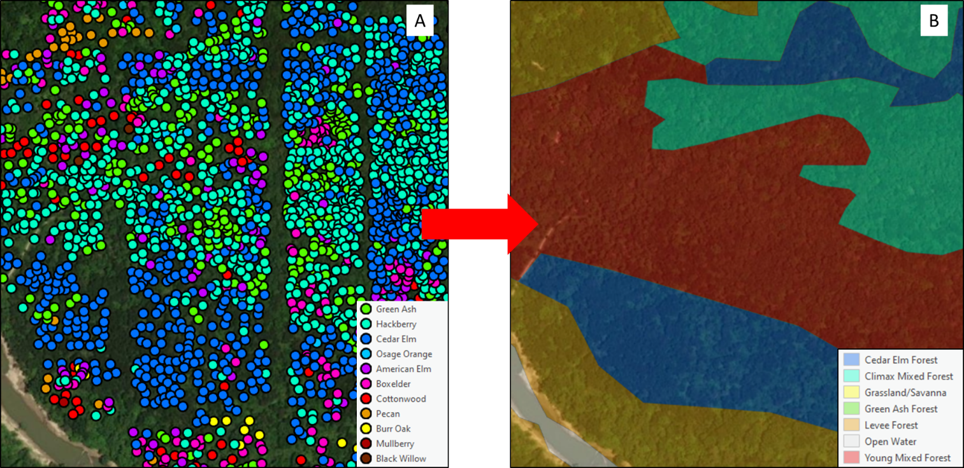
Figure S3 a) Dense imagery allows for enough tree identifications that b) habitat types can be assigned based on canopy tree composition.

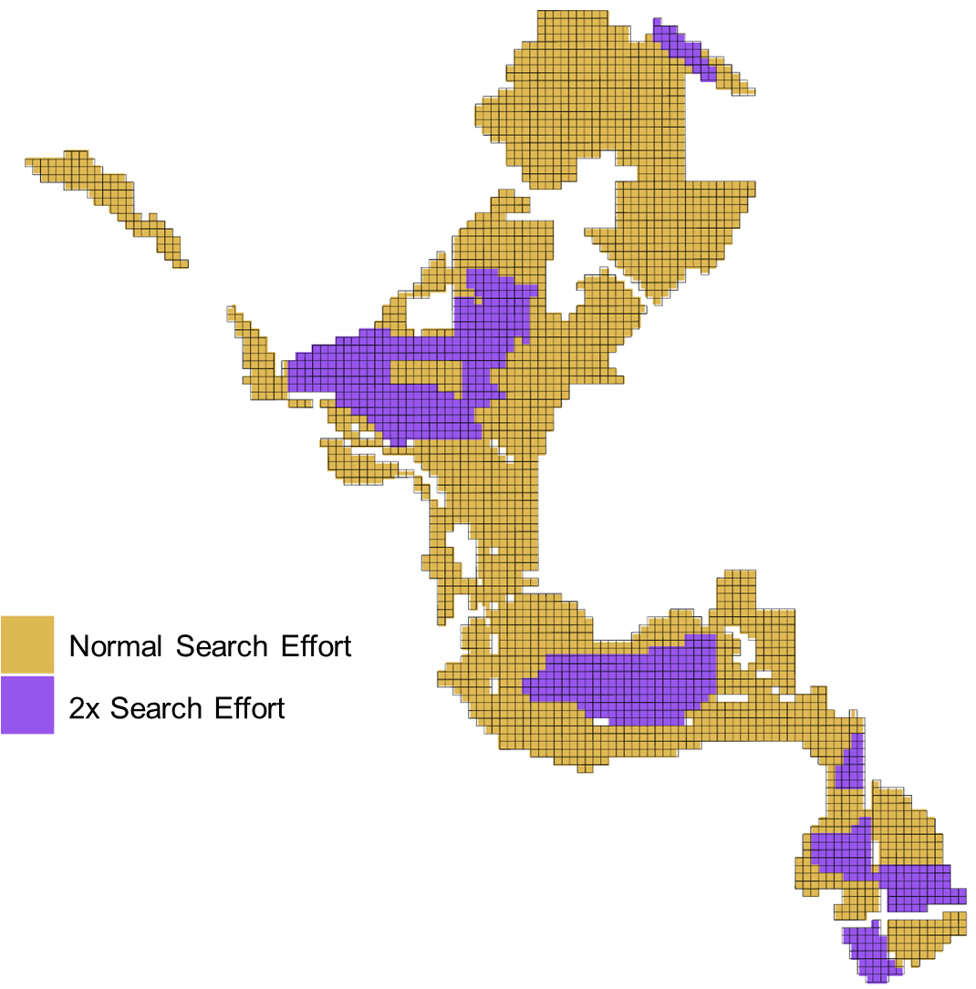Figure S4 Locations where increased search effort to locate swamp rabbit latrines occurred in the Great Trinity Forest, Dallas, TX, USA.

Spatially Segregated Model Parameters for MaxEnt Model
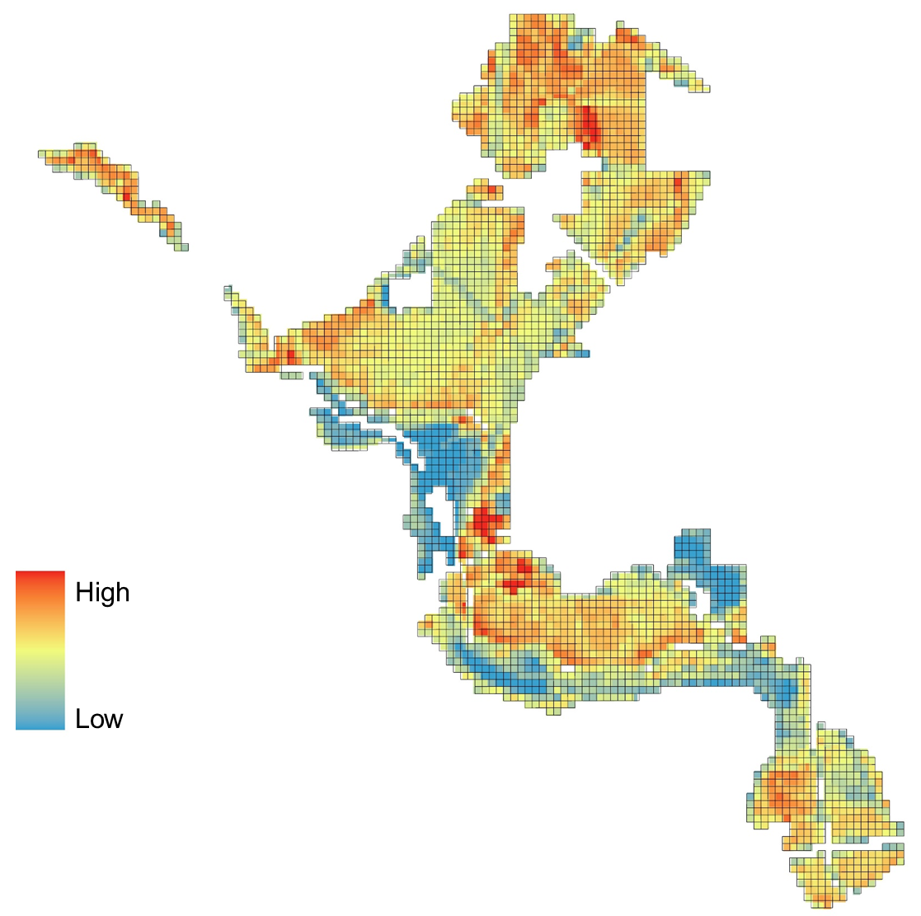
Figure S5 Mean maximum vegetation height in the Great Trinity Forest, Dallas, TX, USA.

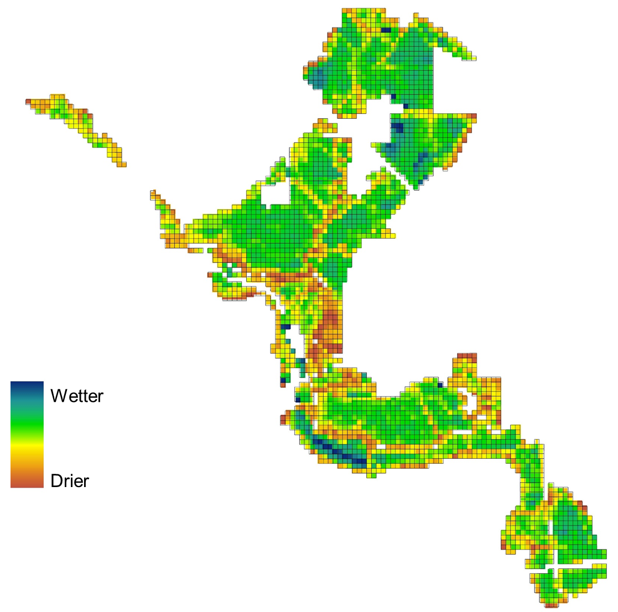
Figure S6 Topographic wetness index in the Great Trinity Forest, Dallas, TX, USA.

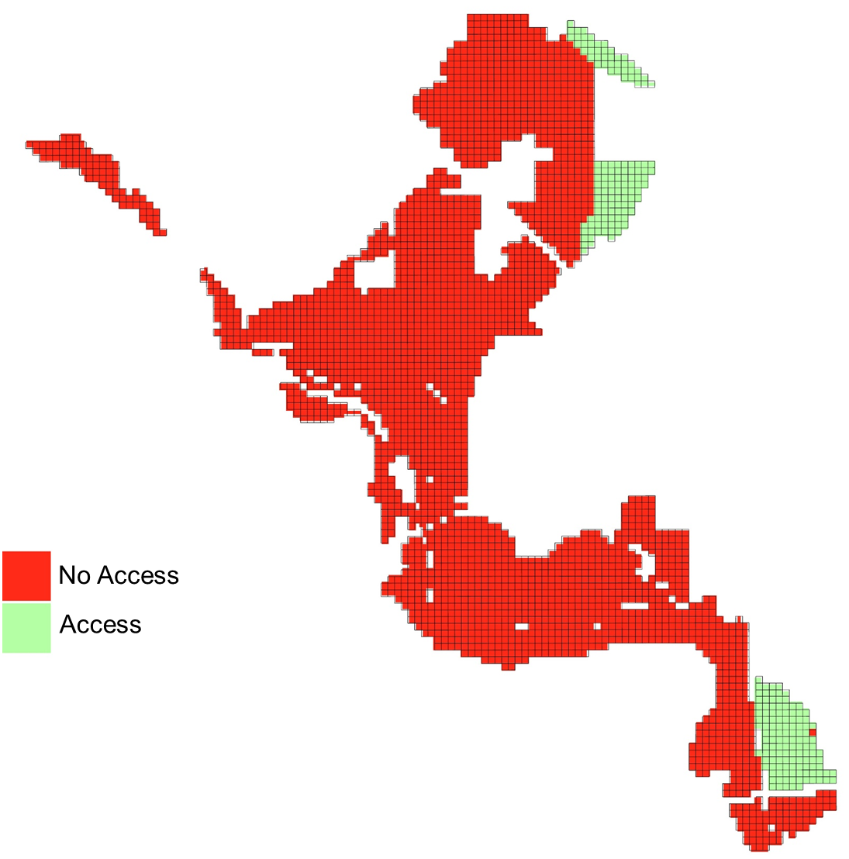
Figure S7 Access to highland refugia in the Great Trinity Forest, Dallas, TX, USA.

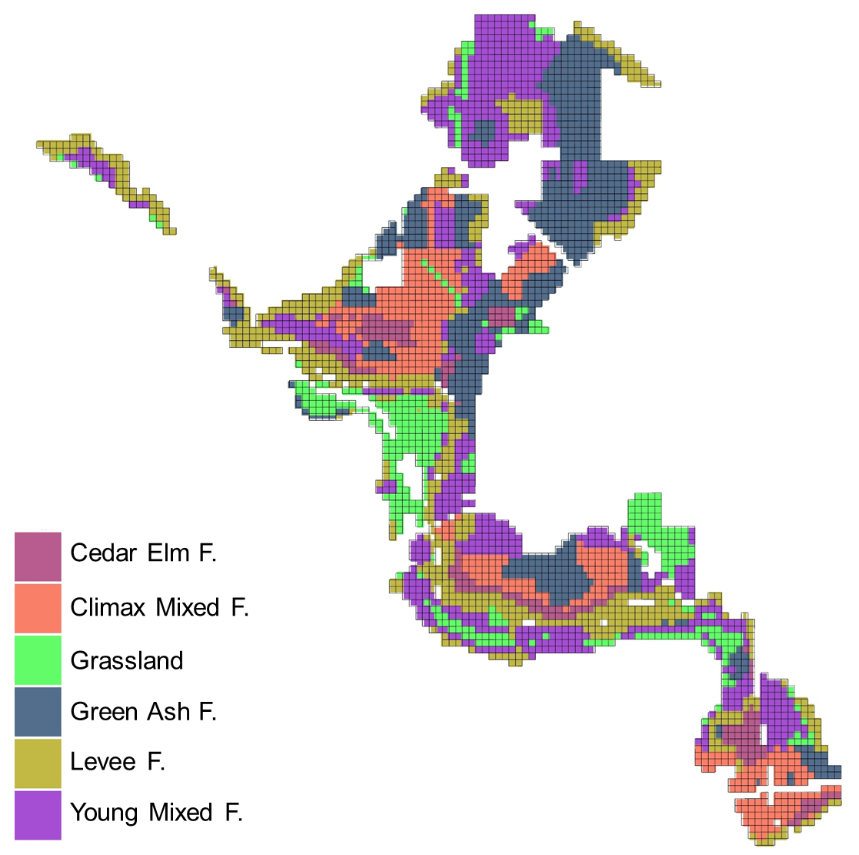
Figure S8 Vegetation Composition in the Great Trinity Forest, Dallas, TX, USA.

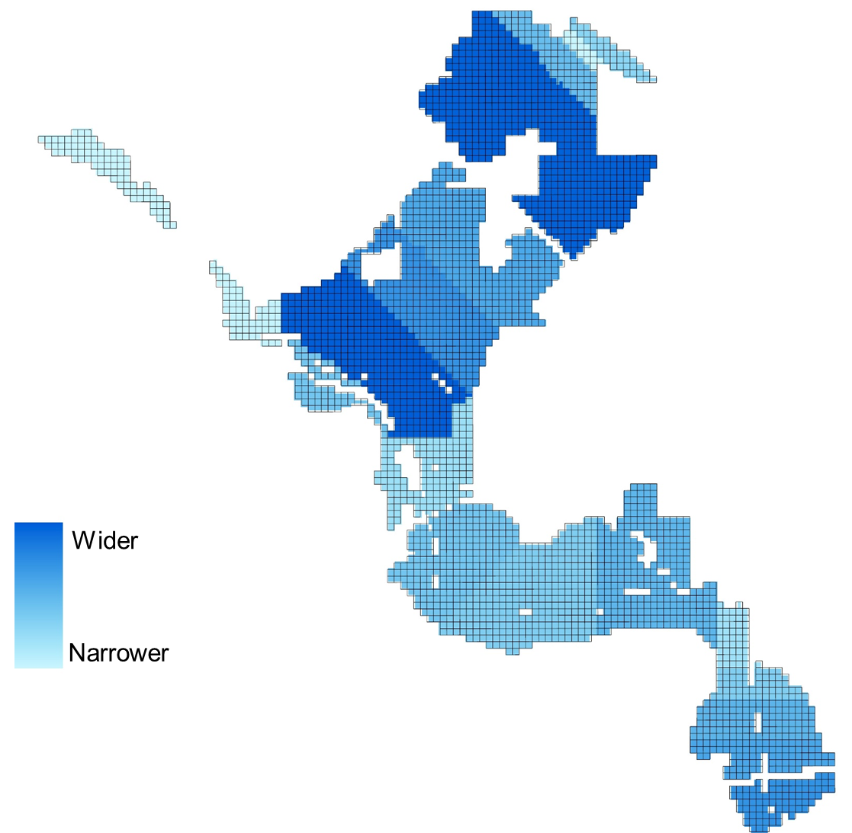
Figure S9 Forest Width in the Great Trinity Forest, Dallas, TX, USA.

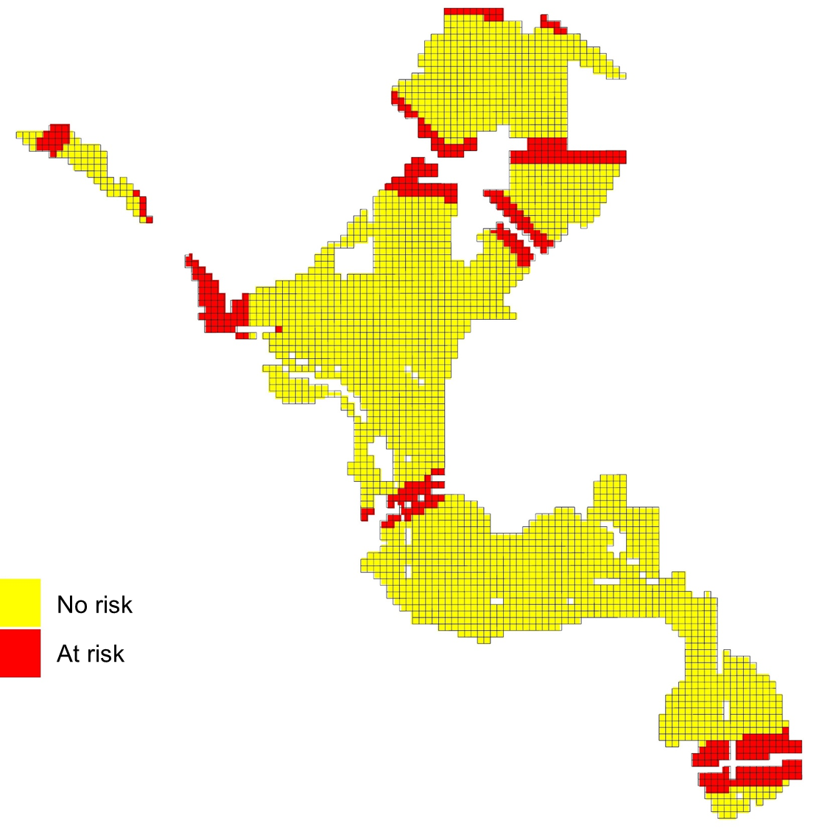
Figure S10 Risk for continuous noise exposure in the Great Trinity Forest, Dallas, TX, USA.

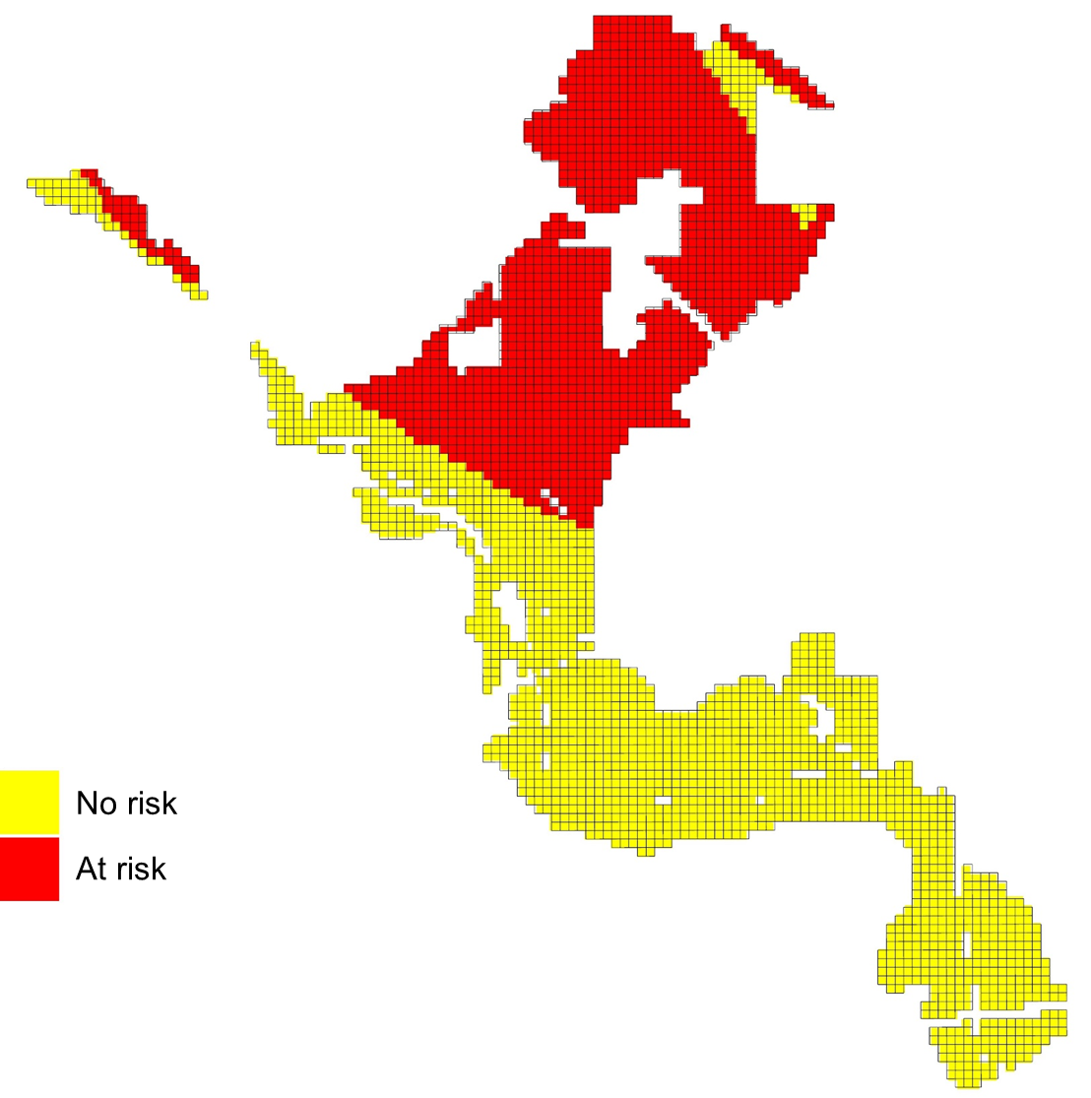
Figure S11 Risk for intermittent noise exposure in the Great Trinity Forest, Dallas, TX, USA.

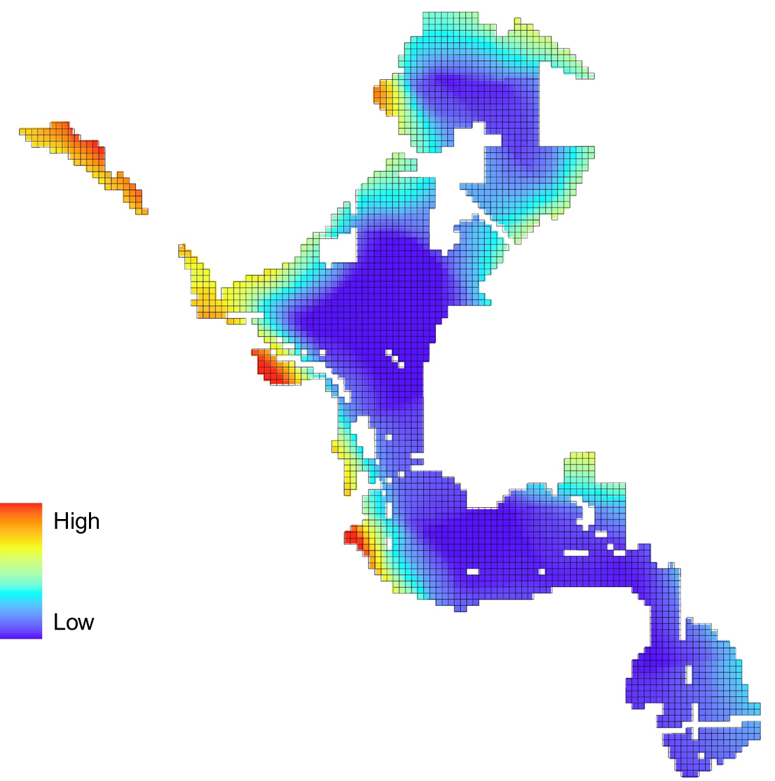
Figure S12 Amount of impervious surface within 1000 meters in the Great Trinity Forest, Dallas, TX, USA.

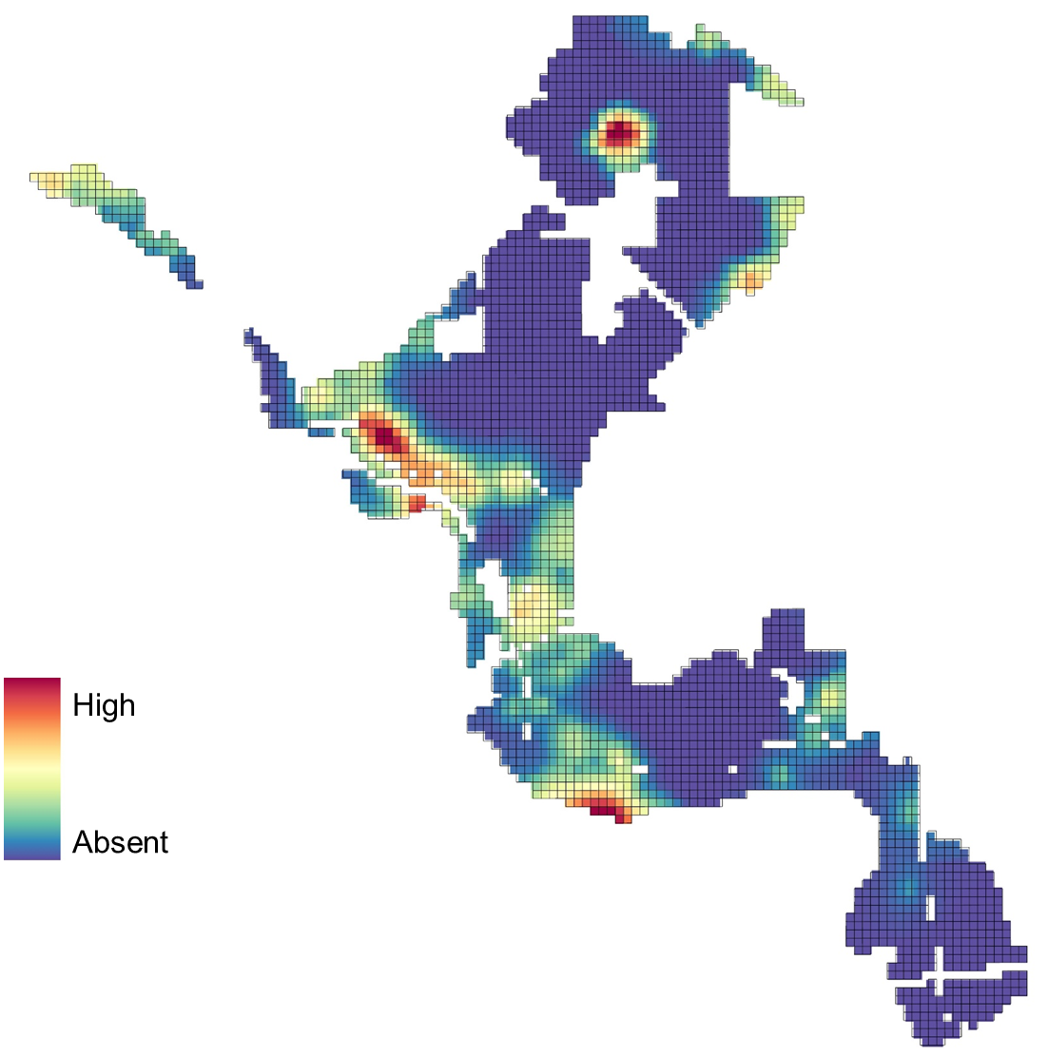
Figure S13 Chinese privet relative abundance in the Great Trinity Forest, Dallas, TX, USA.

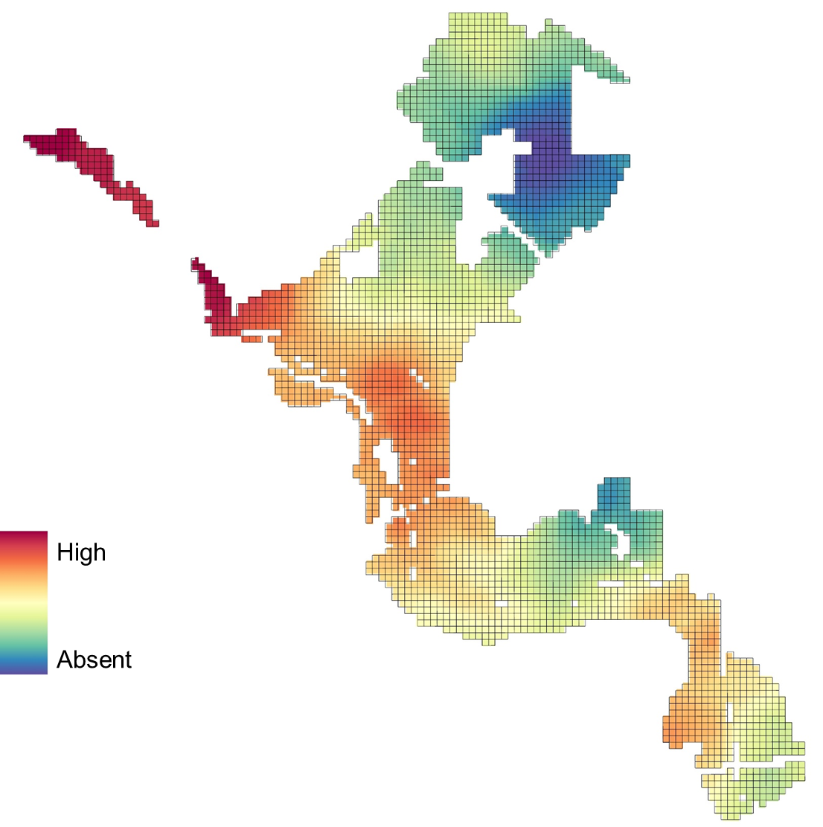
Figure S14 Evidence of feral hog activity in the Great Trinity Forest, Dallas, TX, USA.

