SUPPLEMENTARY MATERIALS

Supplementary Figure S1. Safety-net provider attitudes about
HIV pre-exposure prophylaxis (PrEP)

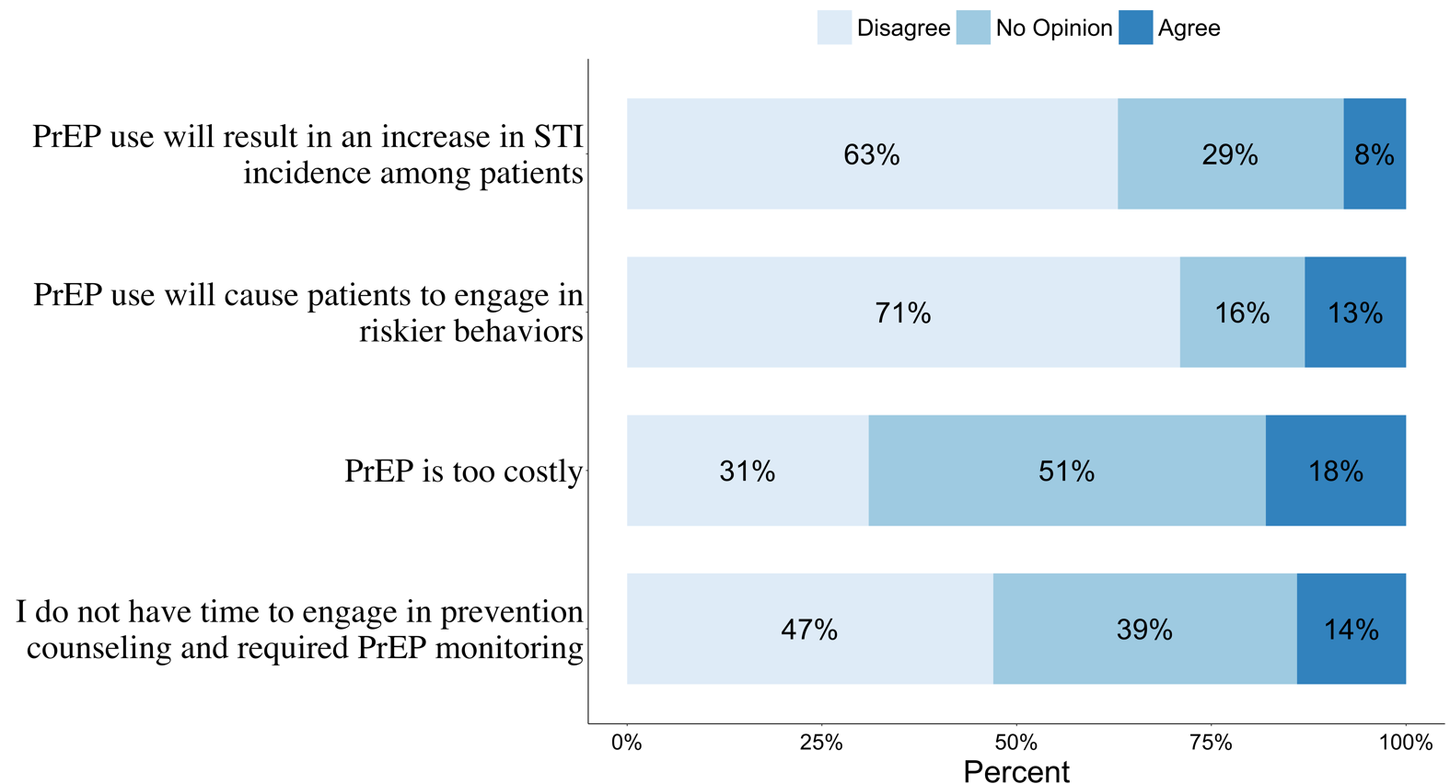

Supplementary Figure S2: HIV pre-exposure prophylaxis (PrEP) educational topics and training preferences by safety-net PCPs

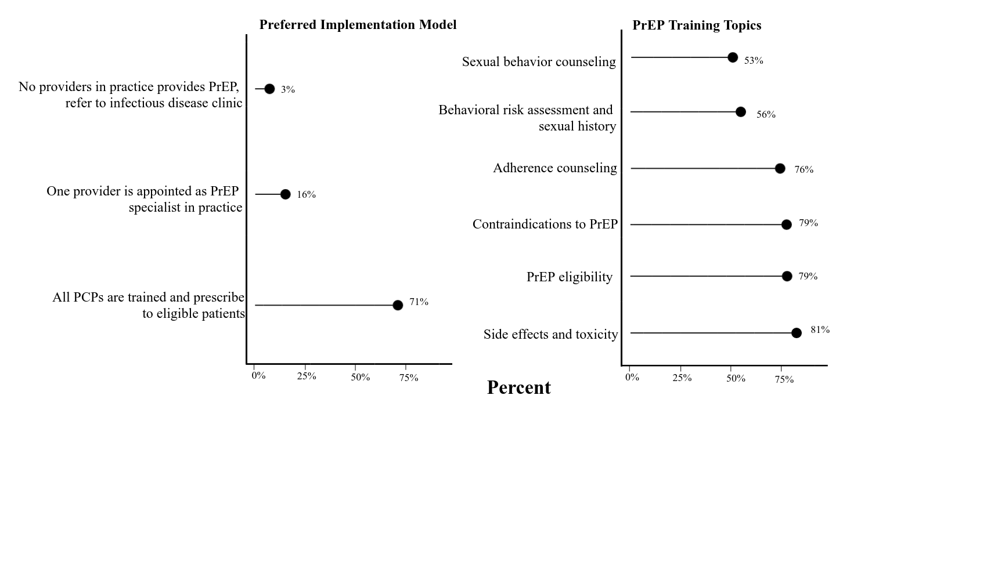

APPENDIX
Survey instrument to assess knowledge and attitudes related to HIV pre-exposure prophylaxis among primary care providers in an urban safety-net health system.
Knowledge and Attitudes to PrEP

- How would you rate your knowledge of HIV pre-exposure prophylaxis (PrEP)?
☐ Never heard of it ☐Low ☐Medium ☐High
- Do you feel that you know enough about PrEP to have an informed discussion with your patients?
☐Yes ☐No
- In the case of monogamous sero-discordant couples, which of the following options would you choose to protect the negative partner from HIV infection? (Select ONE option)
☐Antiretroviral treatment of the HIV positive partner regardless of CD4 count
☐PrEP to the uninfected partner
☐Antiretrovirals to the HIV positive partner and PrEP to the HIV uninfected partner
☐Safer sex counselling only to the uninfected partner
☐Other, please specify _________________________________________________________
- Here are some statements about prescribing and clinical management of PrEP. Please read each statement carefully and mark the box with an X that is closest to your viewpoint. (Give only one answer for each row.)
 | Strongly Agree | Agree | No opinion or Uncertain | Disagree | Strongly disagree
- I am familiar with current research on PrEP safety and efficacy.
- I am comfortable discussing HIV risk factors with my patients.
- I do not have time to engage in prevention counselling and required PrEP monitoring.
- I would feel uncomfortable prescribing PrEP without specific prescribing guidance.
- I am not certain who PrEP is right for.
- PrEP is too costly.
- I am concerned about the potential side effects of PrEP
- I am concerned about a low adherence to PrEP
- The use of PrEP will cause patients to engage in riskier behaviors
- The provision of PrEP will result in an increase in sexually transmitted disease incidence among patients
Practice of PrEP
- Have you been asked by any of your patients about PrEP in the PAST YEAR?
☐Yes ☐No If no, go to question 7
- If yes, who has asked you about PrEP in the PAST YEAR? (check all that apply)
☐Men who have sex with men
☐Person having transactional sex
☐Injecting drug users
☐Person who had a recent bacterial STI
☐HIV uninfected partner in a sero-discordant relationship
☐HIV uninfected partner in a sero-discordant relationship trying to conceive
Other, please specify: __________________
- How many times in the PAST YEAR have you initiated a discussion about taking PrEP as a prevention option with a patient?
☐ 0 ☐ 1-5 ☐ 6-10 ☐10-15 ☐>15
- Is there a risk assessment screening tool available at your practice to screen and identify patients who are at a high risk for HIV?
☐Yes ☐No
- Which of the following statements best applies to you | Agree | Disagree
- I have prescribed or currently prescribe PrEP for HIV Prevention in the PAST YEAR
- I refer patients to other providers who prescribe PrEP
- With more education and training, I would refer patients to other providers who prescribe PrEP
- With more education and training, I would prescribe PrEP
- I will not prescribe PrEP to my patients
- In your opinion, which approach do you think would be most feasible to implement PrEP in your clinical practice setting? (Select ONE option)
☐All providers in the practice should receive training to provide PrEP and prescribe to eligible patients.
☐One provider in the practice is appointed as a PrEP specialist (i.e., a provider who receives specific training on PrEP and to whom all eligible patients in the practice are referred).
☐No providers in the practice should receive training or provide PrEP; rather, patients are referred outside the practice to an infectious disease or STD clinic.
☐Other (please specify) ____________________
Training Needs

- Would you be interested in receiving training on PrEP?
☐Yes Go to question 12 ☐No Go to question 13
- What training topics relating to PrEP will you be interested in? (Check all that apply)
☐Sexual behavior counseling
☐Behavioral risk assessment and sexual history
☐PrEP eligibility
☐Side effects and toxicity
☐Adherence counseling
☐Contraindications to PrEP
☐Other, please specify _________________________________________________________
- What is your preferred training modality? (Check all that apply)
☐In-person training
☐Self-instructed online courses
☐Webinar
☐Online learning resources
☐Tele mentoring with HIV experts
☐Clinical consultation with HIV experts
☐Other, please specify ________________________________________________________
- Gender  ☐Male ☐Female ☐Transgender ☐Other  - Age  ☐ <30  ☐ 31-40  ☐ 41-50  ☐ 51-60  ☐ ≥60  - Race/Ethnicity  ☐White Non-Hispanic  ☐Black Non-Hispanic  ☐Asian  ☐Hispanic  ☐Other, please specify ________________________ | - What is your profession or specialty?  ☐Primary Care Physician  ☐Nurse Practitioner  ☐Physician Assistant  ☐Obstetrician/Gynecologist  ☐Infectious disease specialist  ☐Internal Medicine  ☐Other, please specify ___________________  - After completing residency or training, I have been in practice:  ☐<5 years  ☐5-9 years  ☐10-14 years  ☐15-19 years  ☐≥20 years
Demographics

Adapted from the following surveys

- Blumenthal J, Jain S, Krakower D, et al. Knowledge is Power! Increased Provider Knowledge Scores Regarding Pre-exposure Prophylaxis (PrEP) are Associated with Higher Rates of PrEP Prescription and Future Intent to Prescribe PrEP. AIDS and behavior. 2015; 19 (5):802-810.

- Puro V, Palummieri A, De Carli G, Piselli P, Ippolito G. Attitude towards antiretroviral Pre-Exposure Prophylaxis (PrEP) prescription among HIV specialists. BMC infectious diseases. 2013;13:217.

- Sharma M, Wilton J, Senn H, Fowler S, Tan DH. Preparing for PrEP: perceptions and readiness of Canadian physicians for the implementation of HIV pre-exposure prophylaxis. PloS one. 2014;9(8):e105283.

- Wood BR, McMahan VM, Naismith K, Stockton JB, Delaney LA, Stekler JD. Knowledge, Practices, and Barriers to HIV Preexposure Prophylaxis Prescribing Among Washington State Medical Providers. Sexually transmitted diseases. 2018;45(7):452-458

