ISOLATED IN MY RESENTMENT: OUTCOMES OF EXISTENTIAL ISOLATION AND INCEL TRAITS
SUPPLEMENTAL MATERIALS

by
MATTHEW ALAN ESPINOSA

Bachelor of Arts, 2020
Boston University
Boston, Massachusetts

Master of Science, 2022
Texas Christian University
Fort Worth, Texas

Submitted to the Graduate Faculty of the
College of Science and Engineering
Texas Christian University
in partial fulfillment of the
requirements for the degree of

Doctor of Philosophy

April 2025

Vignettes used for Assessing Self-Reported Rape Proclivity in Study 2
- You have gone out a few times with a woman you met recently. One weekend you go to a film together and then back to your place. You have a few beers, listen to music, and do a bit of petting. At a certain point your friend realizes she has had too much to drink to be able to drive home. You say she can stay over with you, no problem. You are keen to grab this opportunity and sleep with her. She objects, saying you are rushing her and anyway she is too drunk. You don’t let that put you off, you lie down on her and just do it.
- A while back, you met an attractive woman in a disco and you would like to take things a bit further with her. Friends of yours have a holiday home so you invite her to share a weekend there. You have a great time together. On the last evening you are ready to sleep with her, but she says no. You try to persuade her, insisting it’s all part of a nice weekend. You invited her, after all, and she did accept. At that she repeats that she doesn’t want to have sex, but then puts up hardly any resistance when you simply undress her and have sex with her.
- Imagine you are a firm’s personnel manager. You get on especially well with a new female member of the staff. At the end of a busy week, you invite her out to dinner and take her home afterward. As you want to spend some more time in her company, you suggest that she might ask you in for a coffee. Next to her on the sofa, you start fondling her and kissing her. She tries to move out of reach but you tell her that her career prospects stand to be enhanced by her being on good terms with her boss. In due course. She seems to have accepted this, and she doesn’t resist when you have sex with her.
- You are at a party and meet a good-looking and interesting woman. You chat, dance together, and flirt. After the party, you give her a lift home in your car and she invites you in. You both sit down on the floor, then your new friend kisses you and starts to fondle you. That’s absolutely fine with you and now you want more. When you start to undress her in order to sleep with her, she suddenly pushes you off and says she wants to stop now. Her resistance only turns you on more and, using some force, you press her down on the floor and then penetrate her.
- You helped a young woman recently when her car broke down. She invites you to dinner in her apartment as a way of saying thank you. It’s a very pleasant evening and you have the impression she likes you. When your hostess indicates she is beginning to feel rather tired, you are not at all ready to leave. You would rather you finished the evening in bed together and you try to kiss her. At that the woman gets mad and tells you to clear out. Instead, you grab her arms and drag her into the bedroom. You throw the woman onto the bed and force her to have sex with you

Meta-Humanization Article Manipulation Used in Study 4
Human in the Eyes of Women
What does research say about how women view men?
By Blake Carter Ph.D. | Updated on March 22, 2024
Social scientists are interested in studying a process called dehumanization, or the perception that another group of people is less than fully human.
One way to dehumanize is by asking participants, like yourself, to consider how human they consider various groups to be using the following dehumanization scale:

People typically rate their own group as fully human. For example, American participants tend to place the group “Americans” close to the fully human figure at the far-right side of the scale.
However, participants also tend to rate some groups as less evolved than their own group. For example, American participants tend to place group such as “Arabs”, “Russians”, “Somalis”, and “North Koreans” farther away from the fully human figure.
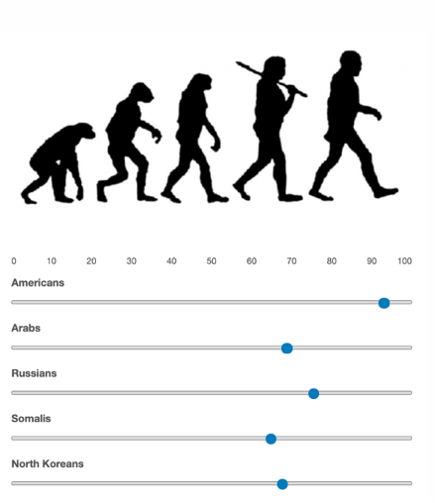
Recently, researchers at Dartmouth College conducted a large-scale study to investigate differences in dehumanization between men and women in the United States.
The researchers asked a nationally-representative sample of men and women to rate how human members of the opposite sex were using the dehumanization scale.
They found that men tend to think that women strongly dehumanize men. They also found that women tend to think that men strongly dehumanize women.
In reality, however, this is not the case. The researchers demonstrated that women rate men as much more human than men tend to think they do. Also, men rate women as much more human than women tend to think they do.
Their data also revealed that women’s ideas about how much men dehumanize them are also grossly exaggerated. That is, men rate women as much more human than women tend to think they do.
In other words, men and women both rate the opposite sex as more human than the opposite sex thinks they do.
The research team additionally found that men and women do NOT differ in the extent to which they dehumanize the other side. That is, there are NO differences between where men place women on the dehumanization scale and where women place men on it.
Put another way, Men and Women think each other are equally human.

Neutral Control Article Manipulation used in Study 4
Productivity Tips and Tricks
What can you do to give yourself time for what really matters?
By Blake Carter Ph.D. | Updated on March 22, 2024
Social scientists are interested in identifying simple strategies we can use to increase productivity through awareness and small behavioral changes.
One way to study productivity is by asking participants, like yourself, how successful you feel when using different strategies types.
Recently, researchers at Dartmouth College conducted a large-scale study to identify different strategies to increase productivity. They include:
- Creating positive habits. Beginning the day with a routine that energizes you, such as dedicating a few moments for one (or more) of the following: mindfulness, motivational reading, gratitude practice, gentle stretches, a 10-minute walk/run, and/or eating a healthy breakfast.
- Write things down. Jotting down your goals on a to-do-list can help declutter your mind and offers opportunities to check off items as you complete them throughout the day.
- Delegate. What can you ask of others to do at home and at work? Are there certain tasks that your partner, child, roommate, etc. can help you with? Even if the task isn’t performed well, could it be good enough?
- Reduce unnecessary time-wasters. For example, rather than running errands intermittently, consider grouping several errands on the same run, perhaps just one or two days per week.
Creating positive habits, writing things down, delegating, and reducing unnecessary time-wasters were rated as highly beneficial to productivity.
But what strategy is viewed as the absolute best for increasing productivity? Perhaps surprisingly, the Dartmouth researchers discovered that induvial in the United States almost universally rated paying attention to times of the day when your energy levels are better for certain things as the most important strategy to use to increase productivity. For example, you may have more energy to exercise in the morning or a greater capacity for deep work on projects in the evening.
Put another way, individuals think matching tasks to your energy level is the best strategy for increasing productivity.

