Appendix A: List of categories and frequency of tweets scraped.
No. | Subgroups (categories) | Hashtags | Number of tweets extracted out of 465 million spritzer streams.  Raw# (unique#) (relevant en/esp#) (manual iteration 5) | Number of topics per category after iteration 5
1 | Electronic cigarette device names, parts, and brand types | #boxmod, #disposablevapepen, #ecig, #ecigar, #ecigarette, #pod, #subohm, #vapepen, #vaporizer, #elfbar, #geekvape, #joyetech, #juul, #Uwell | 38311 (31948) (4621) (334) | 7
2 | Smoking substances | #cannabis, #cbd, #ejuice, #eliquid, #premiumliquid, #vapejuice, #vapor | 32178 (26222) (8783) (1598) | 33
3 | Store names, events, and promotions | #geekvapestore, #geekup, #geekvapetech, #geekfam, #smokeshop, #vapelustion, #vapetime, #Uwelltech, #TPE23, #vapeshop, #vapestore, #vapewholesale | 260 (232) (169) (104) | 2
4 | Vape usernames | #cloudchaser, #vapebabes, #vapecommunity, #vapefam, #vapefriE-cigarettes, #vapelover, #vapenation, #vaper, #vapers, #vapesociety, #vapingcommunity | 743 (632) (432) (393) | 5
5 | Vape adjectives/actions | #vapefun, #smoke, #stopsmokingstartvaping, #vape, #vapeallday, #vapedaily, #vapeadvocacy, #vapelife, #vapelifestyle, #vapelove, #vapelyfe, #vapeon, #vaping, #vapestyle, #vapingsavedmylife | 82352 (61623) (22875) (7889) | 39
6 | Spanish words/associated with Mexico | #vapeadores, #vapear, #VapearNoEsFumar, #vapeo, #vapersmexico | 442 (264) (242) (186) | 4

Hashtags in bold are newly added and meet the following criteria: At least 280 views/likes on a relevant tweet from 2023-2022.
The following hashtags were taken out since they seemed outdated on Twitter:
#blowingclouds, #jualvape, #juulgang, #juulmemes, #juulnation, #juulpod, #juulpods, #juultricks, #juulvapor, #liquidmurah, #popdisposable, #poshplus, #puffbar, #puffbardisposable, #puffglow, #puffplus, #rgvvapes, #saltnic, #smok, #smoktech, #texasvape, #tokovape, #ultimatejuice, #ultimate, #ultimatepuff, #valleyvape, #vapeaddict, #vapeamx, #vapeandomexico, #vapeboy, #vapebuild, #vapecity, #vapeclouds, #vapeclub, #vapedisposable, #vapefamous, #vapegang, #vapegirls, #vapegram, #vapehooligans, #vapehouston, #vapeladies, #vapeliquid, #vapelondon, #vapememe, #vapemex, #vapemexico, #vapemx, #vapeomexico, #vapeomx, #vapeonline, #vapeonthat, #vapeporn, #vapergram, #vapershouts, #vapetricks, #vapeusa, #vapewey, #vapeworld, #vapingisthefuture, #vapingmx
The following hashtags have very a smaller number of results (34 in 465M, probably because they represent images and twitter is mostly text based, hence removed): ‘#vapephoto','#vapephotography','#vapepics','#vapestagram','#instavape.'

Appendix B: frequency by countries (top 20)

Country | Tweets
USA | 227
GBR | 44
CAN | 31
IND | 21
AUS | 20
ZAF | 13
IRN | 10
JPN | 10
KOR | 8
THA | 8
MEX | 8
FRA | 7
VIR | 7
CHN | 6
IRL | 6
NGA | 6
ARE | 5
KEN | 5
ESP | 4

Appendix C: irrelevant keywords eliminated.
Keywords removed from category 1 = ['pea','seed','bean','podcast','radio','episode','listen','iphone','apple','spotify','whale','dolphin', 'youtube','video','audio','show','recording','live','song','check','coffee','capsule','nespresso','arsenal','world','chelsea','football','rugby','soccer','review','invest','podium','instagram','elon','linkedin','delete','escape','space','bath','earth','mars','ocean','tribunal','judicial','trial','just','venez','president','colombia','bugs','shirt','wave','tide','business','demand','holiday','tickets','podcasts','politic','election','education','school','missile','ukraine','twins','birth','airpod','sleep','race','wrestling','trump','media','crypto','bean','nfl','season','tonight','baylor','postgame','game','plays','nba','headphones','earphones','air','mentions','enjoyed','thank','taylor','swift','kravitz','twitter','tweet','battery','paintball','kubernetes','devops','unsubbed','tassimo','entire','card','followers','discount','relx','inf','team','trade','guest','forward','happy','subscribe']
Keywords removed from category 2 = ['seed','ball','perth','australia','booking','sydney','melbourne','plant','traffic','parking','york','onlyfan','camgirl','bank','dog','pet','podcast','trend','nfts','crypto','grow','nairobi','whatsapp','kenya','horny','porn','twitter','election','republi','vote','senate','democrat','russia','ukraine','pain','medical','opioid','patient','metro','bus','residential','route','street','stock','twitter','melatonin','sleep','night','insomnia','media','platform','tax','government','thailand','asia','bankok','california','green','giant','jerry','vicks','chest','nose','rub','anxiety','disorder','earth','atmosphere','water','almond','cook','spinach','biden','president','prison','citizen','holiday','christmas','patriot','navy','christmas','jersey','johannesburg','faded','lounges','arroz','tren','crime','driver','art','cancer','africans','never','friendly','oveja','train','foreigners','roadside','painting','breast','massage','aceite','pepper','mongodb','workstation','wax','trail','company','investing','german','europe','blockchain']
Keywords removed from category 3 = ['ukraine', 'congratulations','thank','winners','please','much','great']
Keywords removed from category 4 = ['ukraine']
Keywords removed from category 5 = ['ukraine','lady','episode','pronouns','zodiac','tattoo','height','radio','podcast','music','radio','twitter','onlyfan','tweet','listen','memory6','distract','mirror','want','would','dont','trump','republican','democrat','election','president','congress','fav','nowplaying','girls','alarms','god','crack','sleep','height','pop','women' ,'alarm' ,'church', 'russian', 'cmere', 'bed', 'tattoos', 'song', 'men', 'test','satan','russia','crackhead', 'nap', 'piercings','listen','ladies' ,'detectors','lord','kyiv', 'dontcha','zodiac','feat' ,'girlfriend','fire' ,'shall', 'moscow','offer','insomnia','pronouns','tyga','mcstan','carbon','bible','donetsk','echelon','ez','playing', 'marry', 'monoxide', 'holy','aiko','drink','home','torment','explosion','pop','shop','gravedigger', 'woo', 'suspects', 'memory', 'killed','rick','years','robbery','choked','watching' ,'somewhere','movie', 'castle', 'headlight', 'compatible', 'machine', 'hammer','sunrise' ,'boston', 'absolute','arctic' ,'train','black', 'palestine','derail','minute','travelling','discount','battery','balloon','fire','plane','christmas','art','igbo',batteries','bomb','theres','flight','year','painting','dey''photoelectric','grenade','wildfires','airport','holiday','paint','werey','beep','fighter','typically','drone','fryd','sketch','seun','game','player','football','eagles','cowboys','turkey','cheese','pork','episode','season','recap','seaweed','water','frozen','ocean','weather','humidity','temperature','democracy','politic','ballot','senator','screen','valentine']

Keywords removed from category 6 = ['ukraine','podcast']

Appendix D.1: Topics generated per iteration per category
 | Category 1 | Category 2 | Category 3 | Category 4 | Category 5 | Category 6
Iteration 1 | 187 | 249 | 2 | 9 | 444 | 5
Iteration 2 | 30 | 50 | 5 | 6 | 100 | 5
Iteration 3 | 40 | 40 | 2 | 5 | 60 | 4
Iteration 4 | 43 | 62 | 2 | 5 | 106 | 4
Iteration 5 | 7 | 33 | 2 | 5 | 39 | 4

Appendix D.2: Average number of tweets per topic per category
 | Category 1 | Category 2 | Category 3 | Category 4 | Category 5 | Category 6
Average # of tweets per topic | 48 | 48 | 52 | 78 | 202 | 47

Appendix E: Heat map for the global & US distribution of all tweets in the categories.

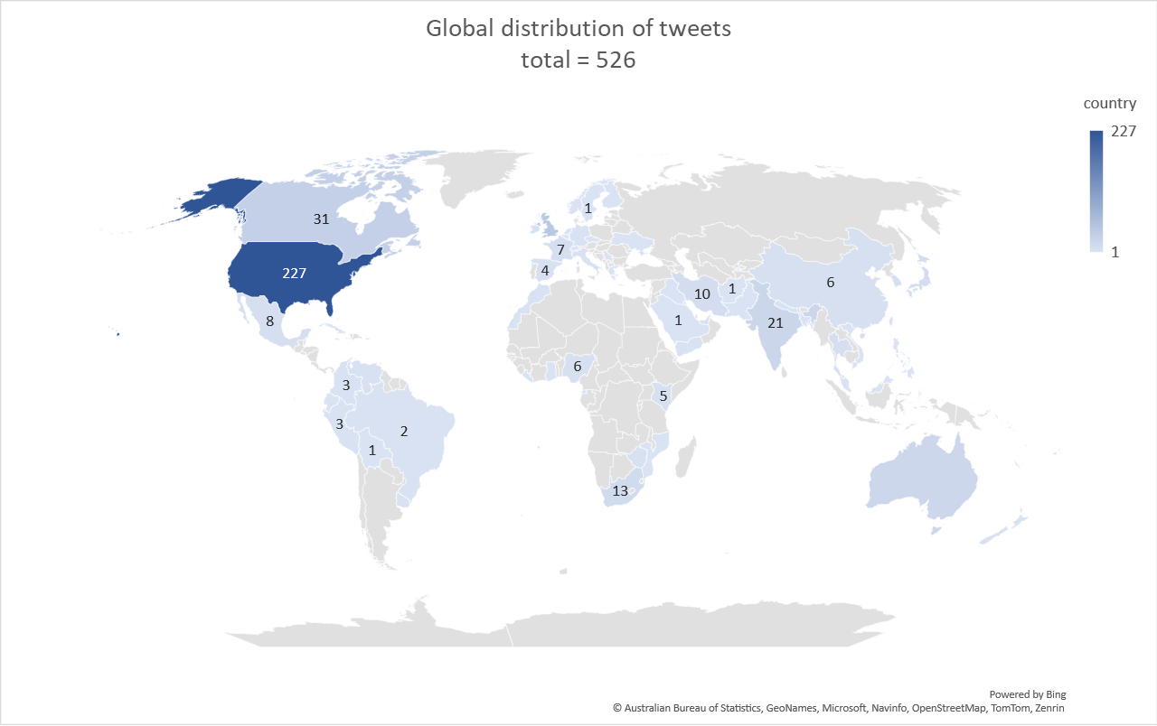
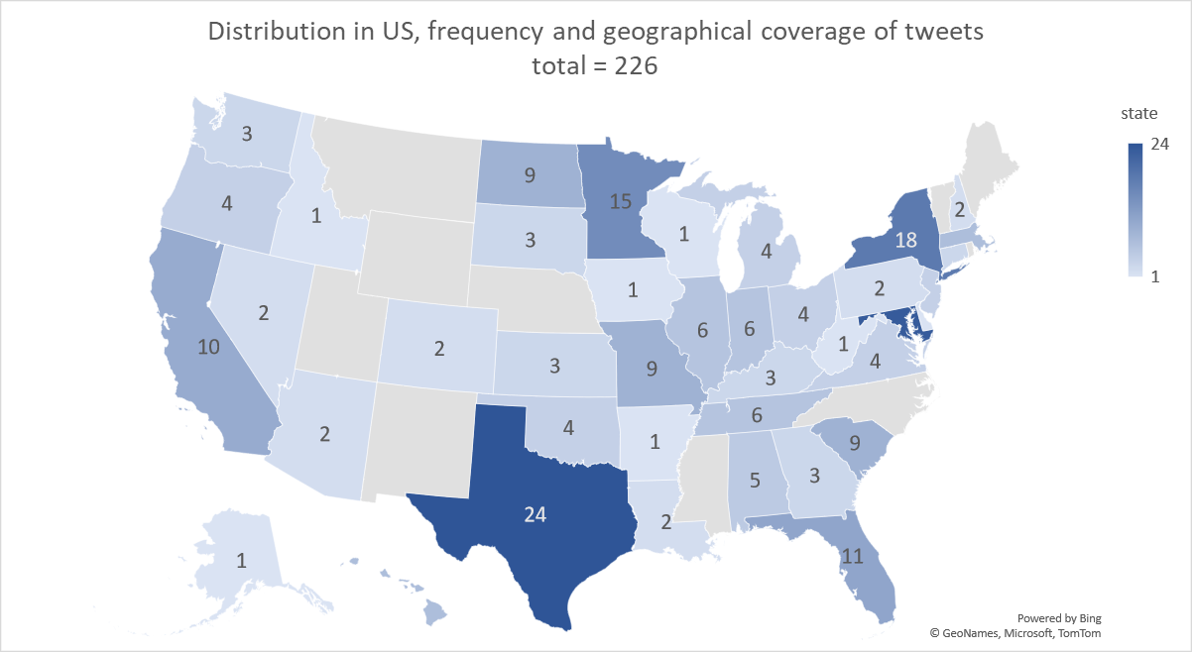

Appendix F.1: Tweets per topic for categories 2 and 5; the values each represent a topic (e.g., topic 0, topic 1, etc.)

Category 2 (N=1598; 33 topics):
144 103 102 97 94 87 61 57 56 55 53 51 49 47 45 43 41 39 37 35 33 31 29 27 25 23 21 19 17 15 13 11 9

Category 5 (N=7889; 39 topics):
3203 1559 659 399 129 128 127 122 117 93 91 88 86 84 82 80 78 76 74 72 68 64 60 56 52 48 44 40 36 32 28 24 20 16 12 10 9 9 8

Appendix F.2: Number of tweets per topic broken down by categories for top 12 topics

 | Category 1 (N=334) | Category 2 (N= 1598) | Category 3 (N= 104) | Category 4 (N= 393) | Category 5 (N= 7889) | Category 6 (N= 186)
Topic 1 | 72 | 144 | 62 | 160 | 3203 | 83
Topic 2 | 69 | 103 | 42 | 105 | 1559 | 52
Topic 3 | 51 | 102 |  | 50 | 659 | 30
Topic 4 | 51 | 97 |  | 47 | 399 | 21
Topic 5 | 39 | 94 |  | 31 | 129
Topic 6 | 35 | 87 |  |  | 128
Topic 7 | 17 | 61 |  |  | 127
Topic 8 |  | 57 |  |  | 122
Topic 9 |  | 56 |  |  | 117
Topic 10 |  | 55 |  |  | 93
Topic 11 |  | 53 |  |  | 91
Topic 12 |  | 51 |  |  | 88

Appendix G: Similarity matrices

Output matrices range from green to blue, with dark blue indicating the strongest relationship between topics and light green indicating the weakest relationships between topics.

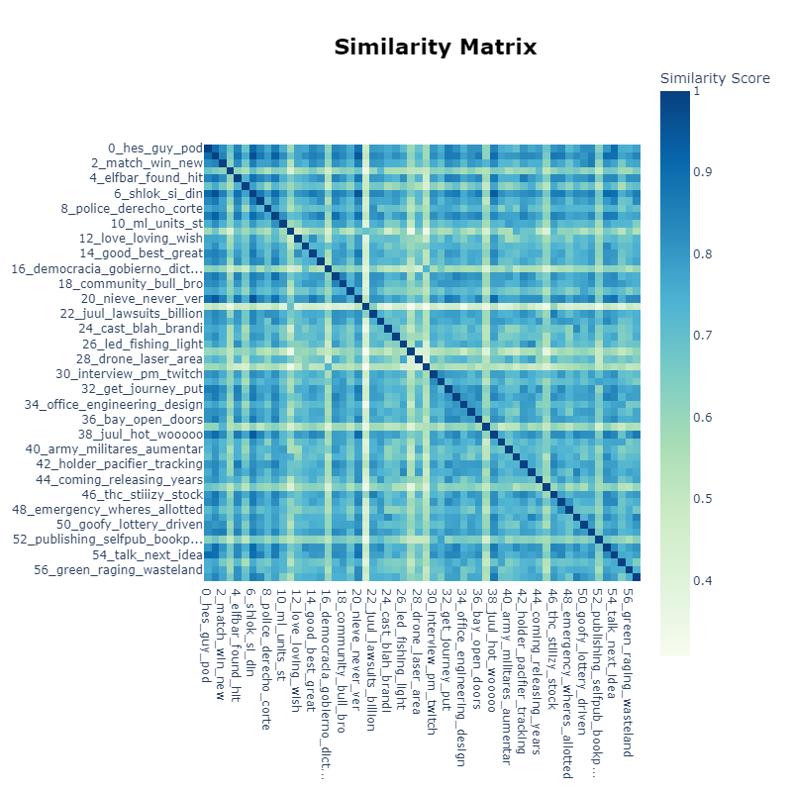
Appendix G.1: Similarity matrix for the topics of category 1

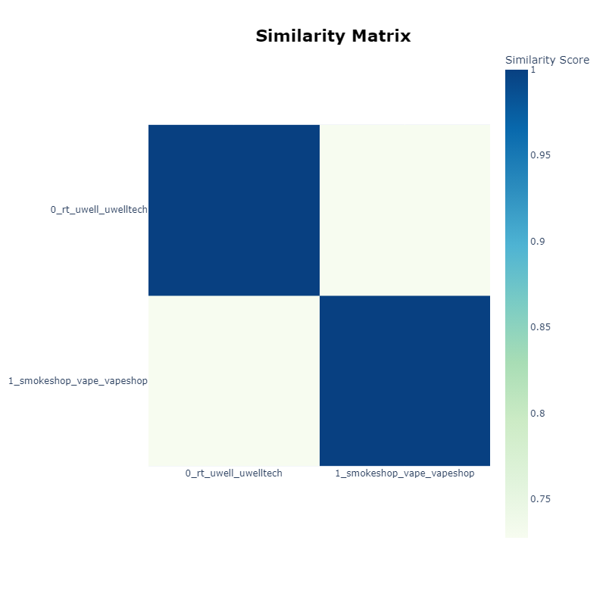
Appendix G.2: Similarity matrix for the topics of category 3

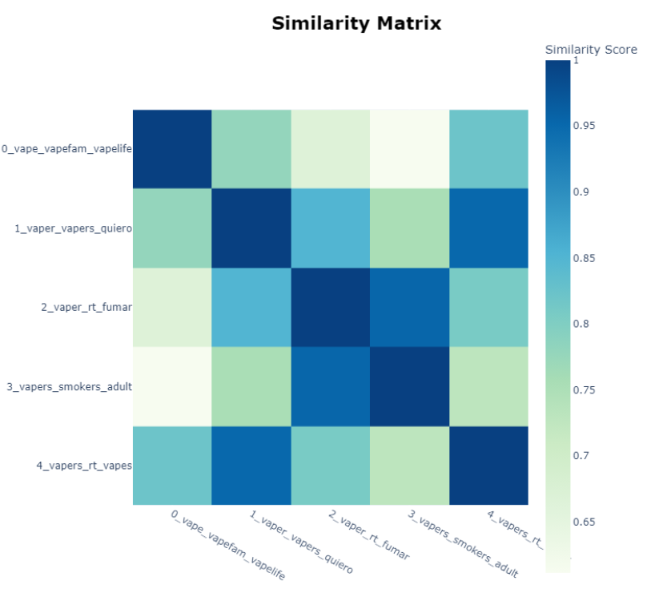
Appendix G.3: Similarity matrix for the 5 topics of category 4
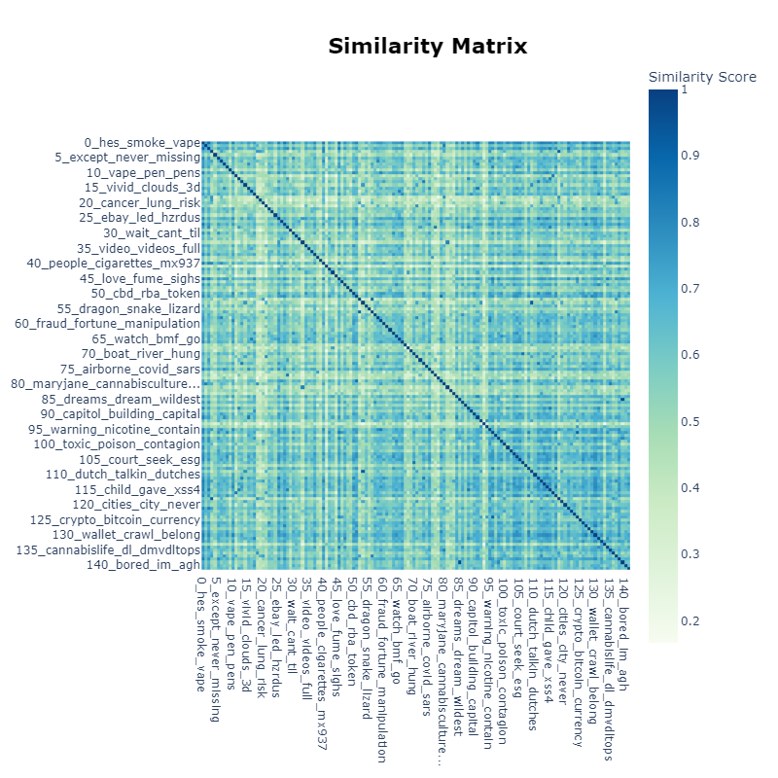
Appendix G.4: Similarity matrix for the topics of category 5
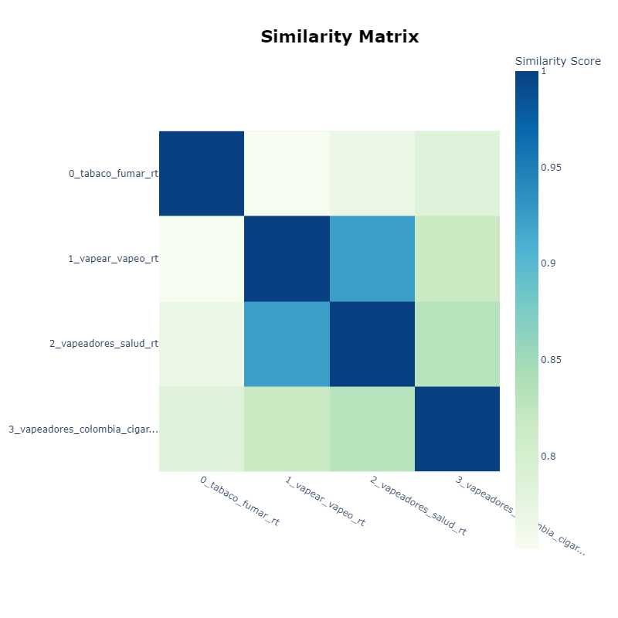
Appendix G.5: Similarity matrix for the topics of category 6

Appendix H: Inter-topic distances
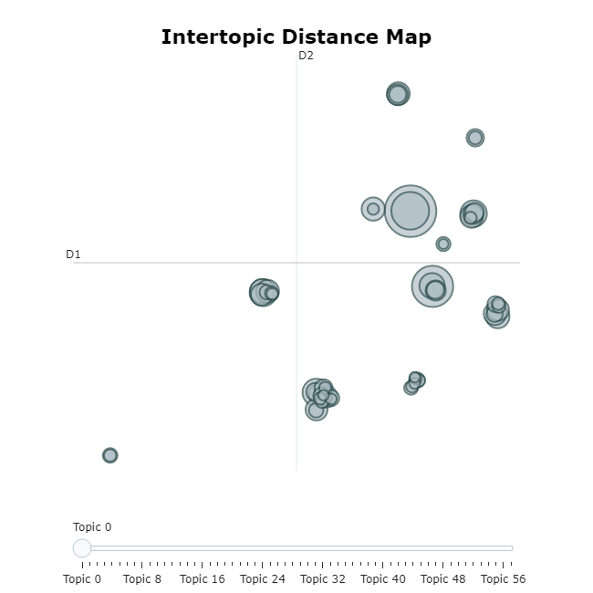
Appendix H.1: Inter-topic map for Category 1

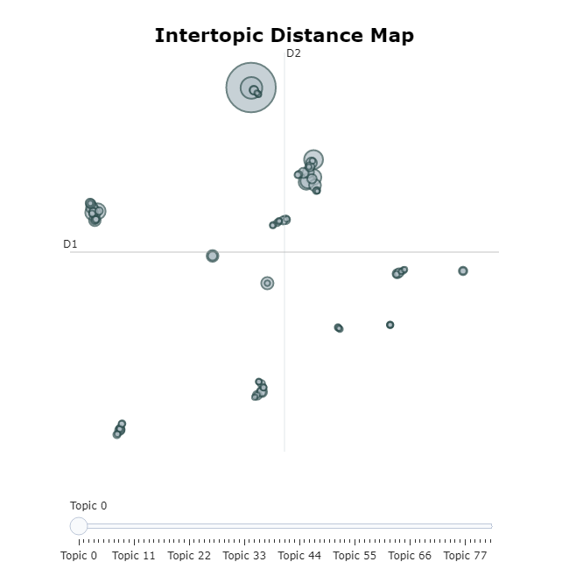
Appendix H.2: Inter-topic map for Category 2
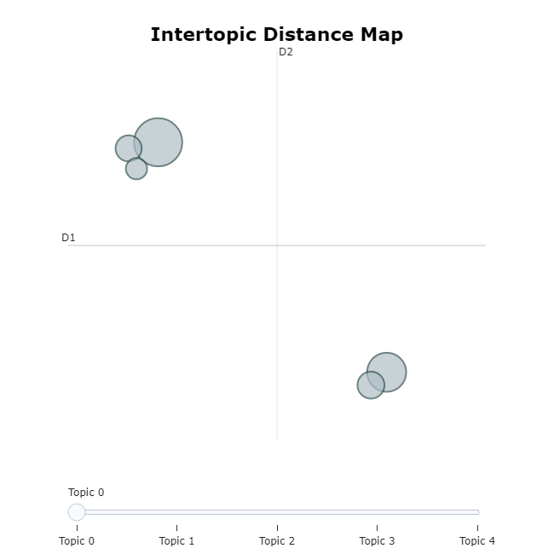
Appendix H.3: Inter-topic map for Category 4

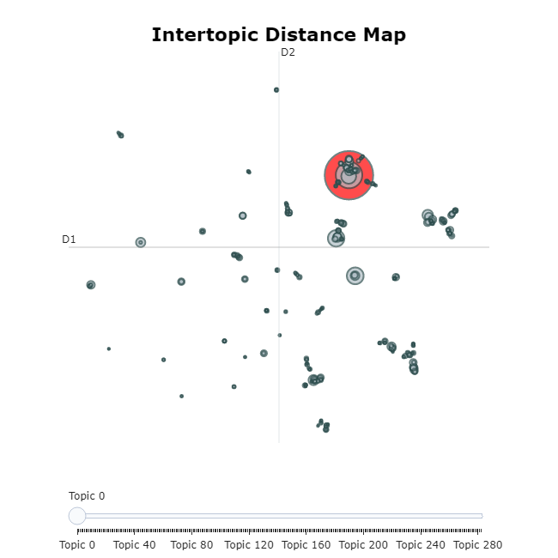
Appendix H.4: Inter-topic map for Category 5

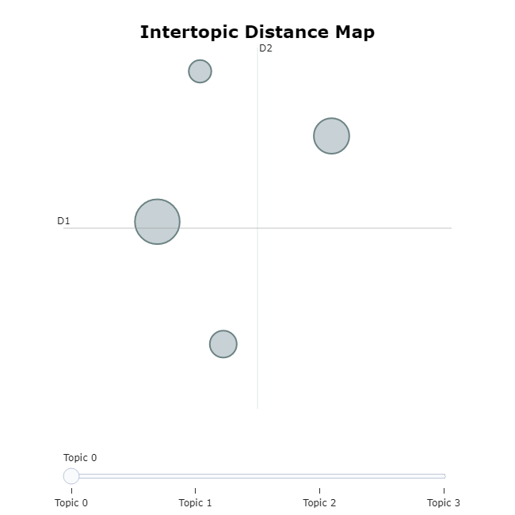
Appendix H.5: Inter-topic map for Category 6

