The Age of Leadership: Meta-analytic Findings on the Relationship Between Leader Age and Perceived Leadership Style and the Moderating Role of Culture and Industry Type

Supplemental Online Material

Table S1 includes a list of all articles used in the meta-analysis to test the hypothesized effects. Figures S1a-S4b include forest plots demonstrating the effect size estimate from each study testing the main effect of leader age on leadership style (only for significant relationships).

Additional Analyses

Leader Age and Leadership Style Perceptions
From the studies on transformational leadership in our sample, we reviewed a subsample to extract information on its dimensions and test our hypotheses for each of its four components: idealized influence, inspirational motivation, intellectual stimulation, and individual consideration.
Idealized Influence
There was a negative and significant relationship between leader age and idealized influence (k = 22; N = 5,391; r = -.14, SD_{r} = .26, SD_{res}= .25, ρ = -.15, SDp = .29, 95% CI = [-.29, -.02], 80% CV = [-.54, .23], p < .05; 6% of total variance explained; see Figure S1b). The Begg and Mazumdar’s rank correlation test indicated small study bias (p = .0003), as well as the trim-and-fill method which revealed asymmetry, particularly missing studies on the right side of the plot, outside of the funnel. On the contrary, Egger’s regression test suggested no presence of small study bias (p = .48). When it comes to publication bias, the weight-function model method indicated presence of said bias (p = .006). Similarly, a fail-safe N estimation of 42 suggested a small number of missing studies (below Rosenberg’s [2005] suggested critical value of 5N+10) needed to push the opposing overall effect size to a significant value, thus indicating some bias.
We also explored the subcomponents of idealized influence: idealized attributes and idealized behaviors.
Idealized Attributes. We found a significant negative main effect of leader age on idealized attributes (k = 15; N = 3,986; r = -.11, SD_{r} = .09, SD_{res}= .07, ρ = -.13, SDp = .08, 95% CI = [-.19,- .07], 80% CV = [-.23, -.02], p < .05; see Figure S1c). This model explained 45% of the total heterogeneity. The Begg and Mazumdar’s rank correlation test, Egger’s regression test of plot asymmetry and weight-function model method indicated no small study and publication bias (p = .99, p = .09, and p = .47, respectively). Additionally, the trim-and-fill method depicted an approximately symmetrical distribution around the mean, suggesting no missing null studies, and only the possible lack of a few studies with small samples and small effect sizes. This test generally alleviated concerns about small study bias. Consistently, a fail-safe N estimation of 108 (above Rosenberg’s [2005] suggested critical value) indicated that a large number of studies is needed to wipe the significance of the effect size, thus again alleviating concerns of bias.
Idealized Behaviors. We did not find a significant relationship between leader age and idealized behaviors (k = 13; N = 3,907; r = -.04, 95% CI = [-.14, .06]; p > .05). The Begg and Mazumdar’s rank correlation test, weight-function model method, and Egger’s regression test indicated no small study or publication bias (p = .44, p = .37, and p = .93, respectively). The trim-and-fill method also indicated symmetry, thus largely alleviating concerns of bias.
Inspirational Motivation
There was a significant negative relationship between leader age and inspirational motivation (k = 22; N = 7,685; r = -.14, SD_{r} = .21, SD_{res}= .20, ρ = -.15, SDp = .22, 95% CI = [-.26,- .05], 80% CV = [-.44, .14], p < .05; 6% of total variance explained; see Figure S1d). The Begg and Mazumdar’s rank correlation test indicated small study bias (p < .0001) and the weight-function model method indicated presence of publication bias (p = .02). The trim-and-fill method revealing missing studies on the right side of the plot, outside of the funnel, also intensified concerns about bias. However, Egger’s regression test of plot asymmetry (p = .45) and a fail-safe N estimation of 286 (above Rosenberg’s critical value) suggested no presence of small study bias.
Intellectual Stimulation
There was also a significant negative relationship between leader age and intellectual stimulation (k = 33; N = 9,119; r = -.12, SD_{r} = .19, SD_{res}= .18, ρ = -.13, SDp = .20, 95% CI = [-.21,- .05], 80% CV = [-.39, .13], p < .05; 10% the total variance explained; see Figure S1e). The Begg and Mazumdar’s rank correlation test (p = .49) and Egger’s regression test of plot asymmetry (p = .74) alleviated concerns of small study bias. Further, a fail-safe N estimation of 300 suggested that a large number of missing studies is needed to make the observed significant effect size nonsignificant, thus refuting concerns for bias. However, the trim-and-fill method, revealing some missing studies on the right side of the plot, outside of the funnel, was indicative of some extant bias. The weight-function model method also indicated presence of publication bias (p = .03).
Individual Consideration
We found a significant negative relationship between leader age and individual consideration (k = 27; N = 8,138; r = -.14, SD_{r} = .22, SD_{res}= .22, ρ = -.16, SDp = .25, 95% CI = [-.27,- .05], 80% CV = [-.49, .17], p < .05; 7% the total variance explained; see Figure S1f). The Begg and Mazumdar’s rank correlation test (p < .0001) and the trim-and-fill method depicting asymmetry (namely, missing studies on the right side of the plot, outside of the funnel) indicated presence of small study bias. The weight-function model method additionally indicated presence of publication bias (p = .003). However, Egger’s regression test of plot asymmetry (p = .71) and a fail-safe N estimation of 285 (above Rosenberg’s critical value) alleviated concerns of small study bias. Taken together, these tests generally alleviated concerns of present bias.
The Moderating Role of Culture
Idealized Influence
We did not find a moderating effect of institutional collectivism (p = .79), power distance (p = .68), or uncertainty avoidance (p = .95).
Idealized Attributes. We did not find a significant moderating effect of institutional collectivism (p = .16). However, power distance significantly moderated the relationship between leader age and perceived idealized attributes, such that the effect was more negative the higher the society’s power distance (b = -.23, t = -4.10, 95% CI = [-.36, -.11], p = .002; see Figure S6a). We also did not find significant moderating effects of uncertainty avoidance (p = .51).
Idealized Behaviors. There was no moderating effect of institutional collectivism (p = .90), or power distance (p = .36), and although there was a significant moderating effect of uncertainty avoidance (b = .19, t = 2.25, 95% CI = [.002, .37], p = .048), its direction was opposite to our hypothesis (see Figure S6b); the effect was less negative in high uncertainty avoidance countries. These results suggest that followers show a stronger bias against older leaders, perceiving them as demonstrating less idealized behaviors, in societies that are more comfortable with uncertainty. Such cultures may be classified as more progressive, ultimately supporting the younger generation more than the older one (e.g., “out with the old, in with the new” mentality) and exhibiting a stronger bias against older leaders. Again, however, as we stated in the main text, these results should be treated with caution.
Inspirational Motivation
There was no significant moderating effect of institutional collectivism (p = .95), power distance (p = .49), or uncertainty avoidance (p = .87).
Intellectual Stimulation
We did not find a moderating effect of institutional collectivism (p = .81), power distance (p = .52), or uncertainty avoidance (p = .68).
Individual Consideration
We did not find a moderating effect of institutional collectivism (p = .93), power distance (p = .77), or uncertainty avoidance (p = .92).
Although we did not hypothesize that culture will moderate the relationship between leader age and less active leadership styles, we test the moderating effect of the three cultural dimensions for completeness.
Passive leadership
We did not find a significant moderating effect of institutional collectivism and power distance cultural dimensions on the relationship between leader age and passive leadership style (institutional collectivism: p = .31; power distance: p = .51). However, uncertainty avoidance significantly moderated the relationship, b = .12, t = 2.18, 95% CI = [.006, .23], p = .04 (see Figure S5a), such that older leaders were perceived as more passive in cultures with high uncertainty avoidance, compared to cultures who have higher uncertainty tolerance.
Management-by-exception-passive. We did not find a moderating effect of institutional collectivism (p = .59) or power distance (p = .88). However, we found a moderating effect of uncertainty avoidance (b = .12, t = 2.71, p = .01; see Figure S5b), whereby the positive relationship between leader age and management-by-exception-passive was more positive among high uncertainty avoidance societies.
Laissez-faire. There was no significant moderating effect of neither cultural dimension on the relationship between leader age and laissez-faire (institutional collectivism: p = .71; power distance: p = .67; uncertainty avoidance: p = .97).
The Moderating Role of Industry Type
Industry type did not significantly moderate the relationship between leader age and neither dimension of transformational leadership: idealized influence (p = .96), idealized attributes (p = .97), idealized behaviors (p = .10), inspirational motivation (p = .83), intellectual stimulation (p = .75), and individual consideration (p = .85).
Exploratory Moderator Analyses: Rater Identity
We found that source of leadership rating moderated the relationship between leader age and idealized attributes (k = 18; N = 4,373; F[1,16] = 15.02, p = .001; 68% of the total variance explained). As for transformational leadership, the relationship between leader age and follower-rated idealized attributes was significantly more negative when leadership style was reported by followers (b = -.27, t = - 3.88, 95% CI = [-.42, -.12], p = .001).
We also tested the moderating effect of rater identity for the other transformational dimensions. Rater identity did not yield a significant moderating effect for the rest of the dimensions (idealized influence: p = .80; idealized behaviors: p = .27; inspirational motivation: p = .59; intellectual stimulation: p = .18; individual consideration: p = .48).

Table S1

Included Studies in the Meta-Analysis
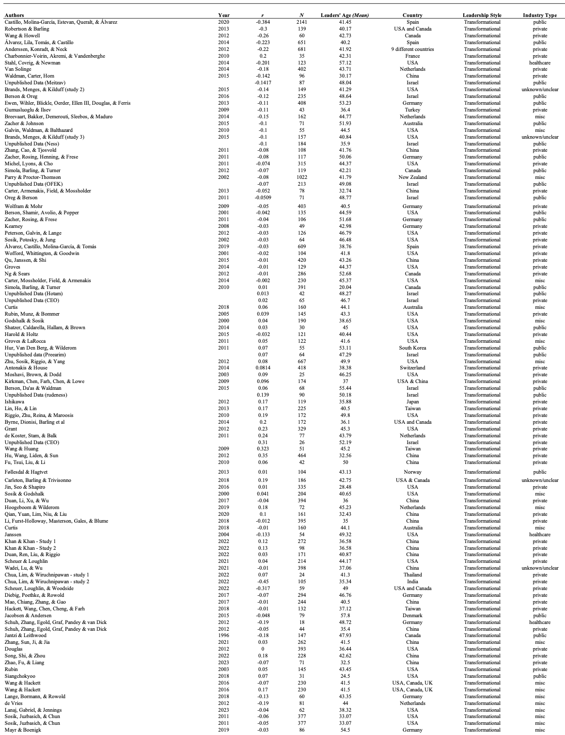
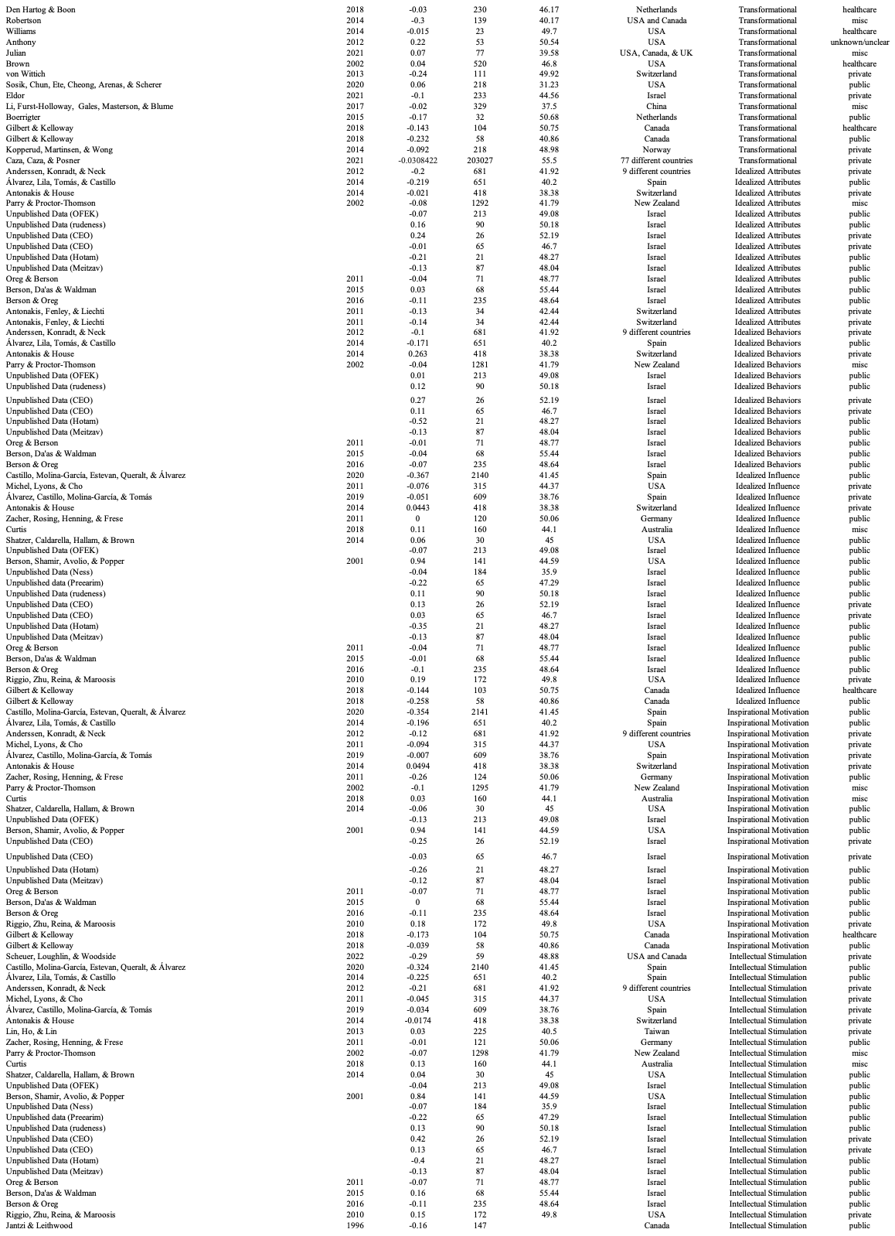
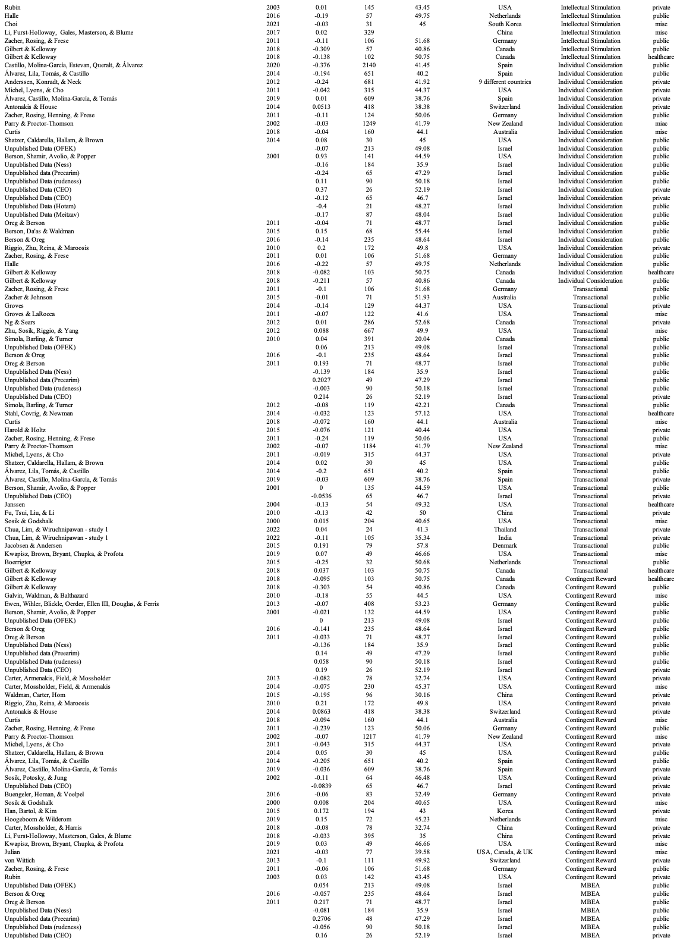

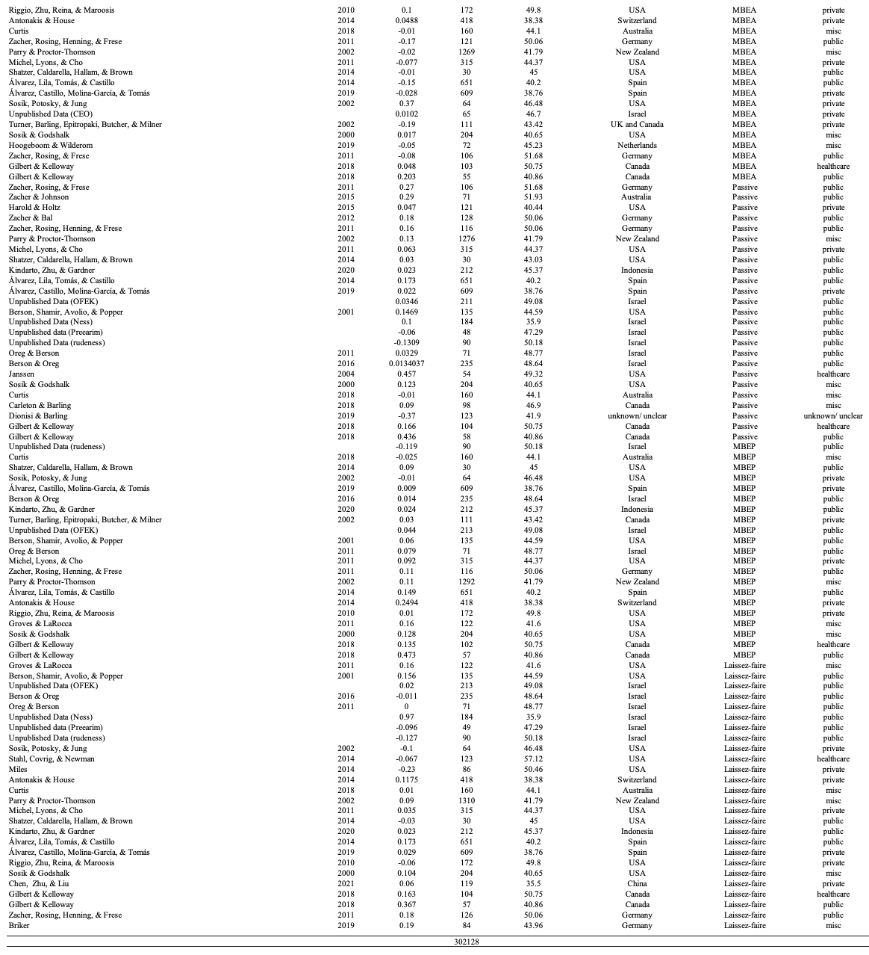
Figure S1a

Forest Plot – Transformational Leadership
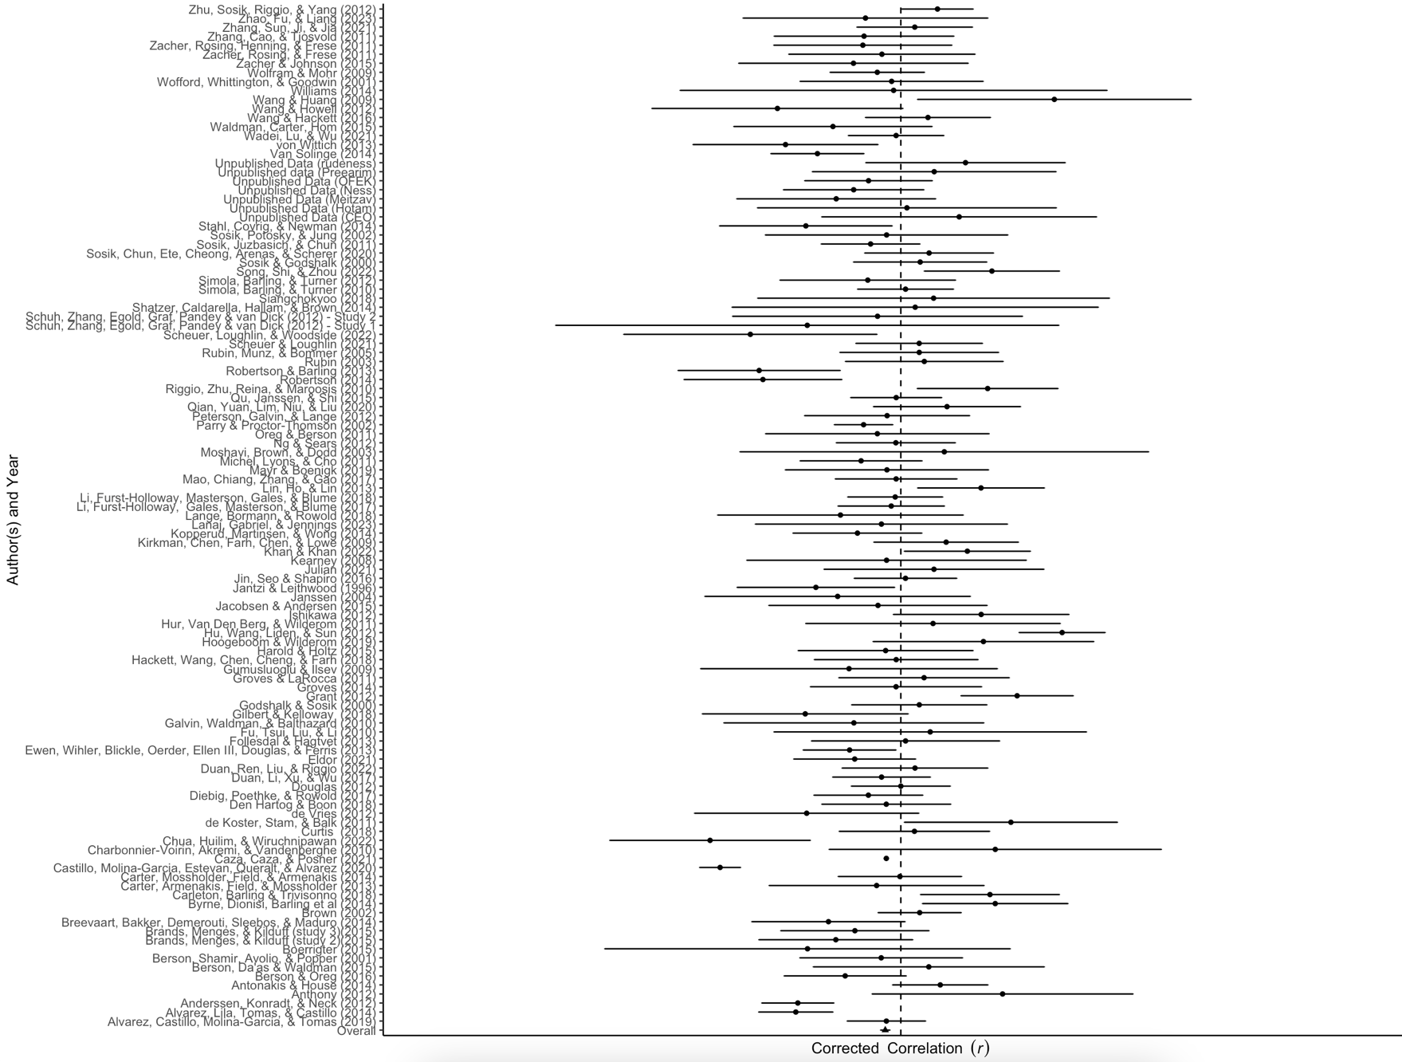
Note: Each row shows the effect size estimate from each study included in the transformational leadership sample (corrected correlations r). The horizontal black line represents the width of the confidence interval. When the line does not touch the effect size 0, which is represented by the black vertical dotted line, it suggests that the effect is statistically significant.

Figure S1b

Forest Plot – Idealized Influence

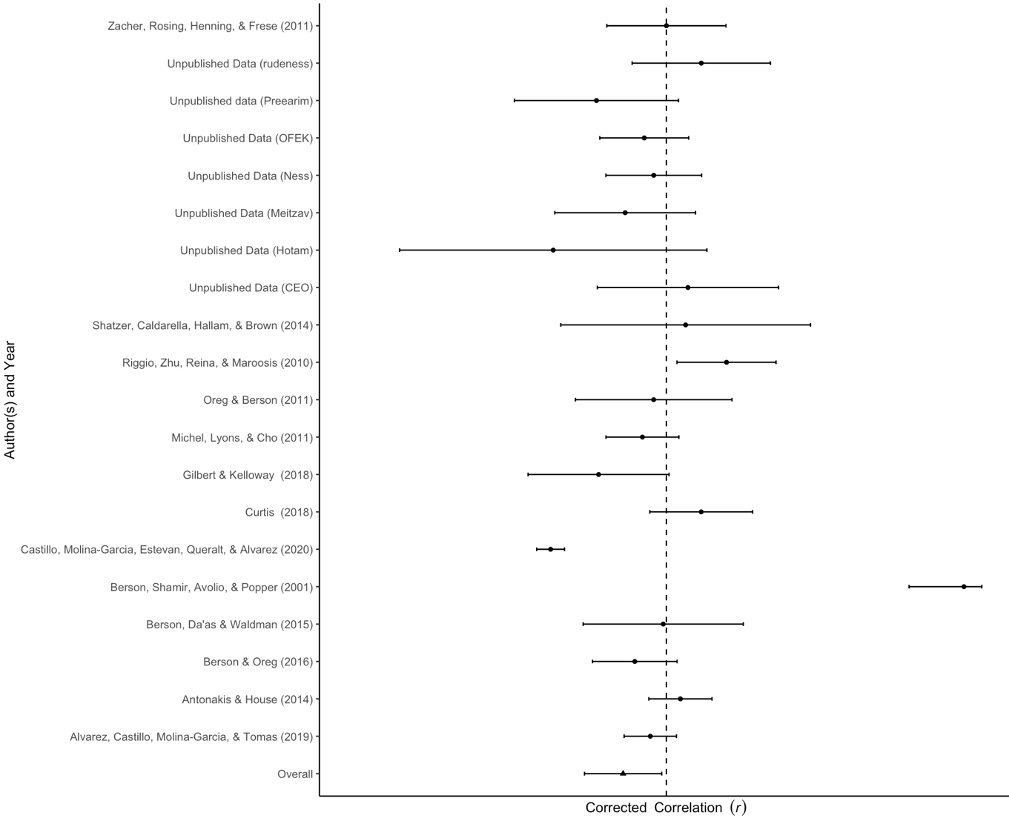
Note: Each row shows the effect size estimate from each study included in the idealized influence sample (corrected correlations r). The horizontal black line represents the width of the confidence interval. When the line does not touch the effect size 0, which is represented by the black vertical dotted line, it suggests that the effect is statistically significant.

Figure S1c

Forest Plot – Idealized Attributes
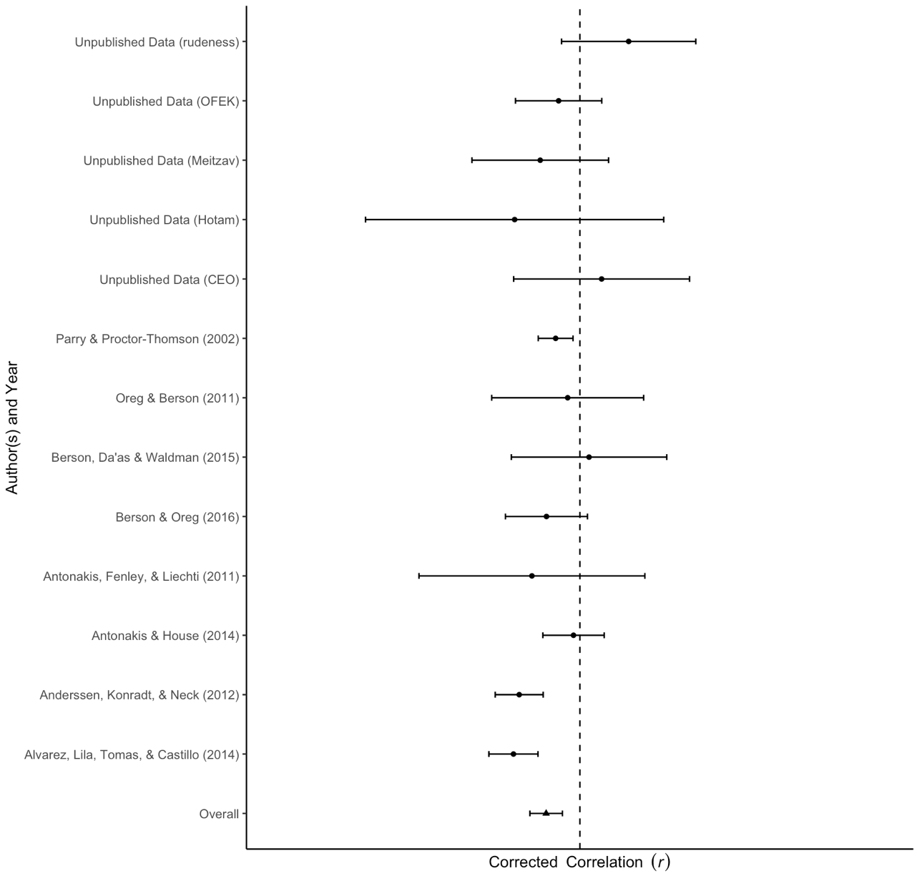
Note: Each row shows the effect size estimate from each study included in the idealized attributes sample (corrected correlations r). The horizontal black line represents the width of the confidence interval. When the line does not touch the effect size 0, which is represented by the black vertical dotted line, it suggests that the effect is statistically significant.

Figure S1d

Forest Plot – Inspirational Motivation
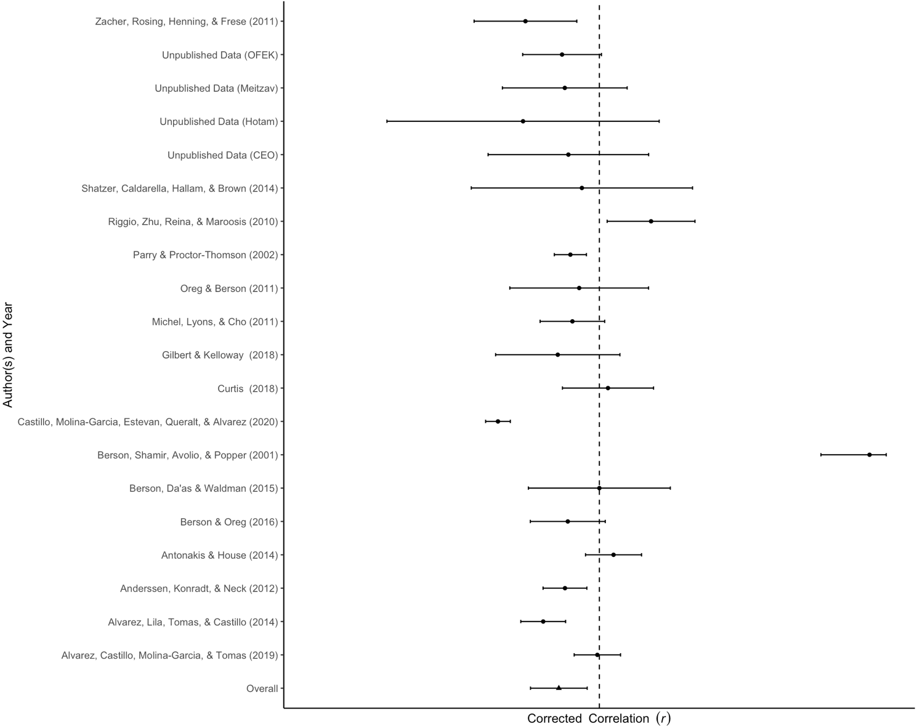

Note: Each row shows the effect size estimate from each study included in the inspirational motivation sample (corrected correlations r). The horizontal black line represents the width of the confidence interval. When the line does not touch the effect size 0, which is represented by the black vertical dotted line, it suggests that the effect is statistically significant.

Figure S1e

Forest Plot – Intellectual Stimulation
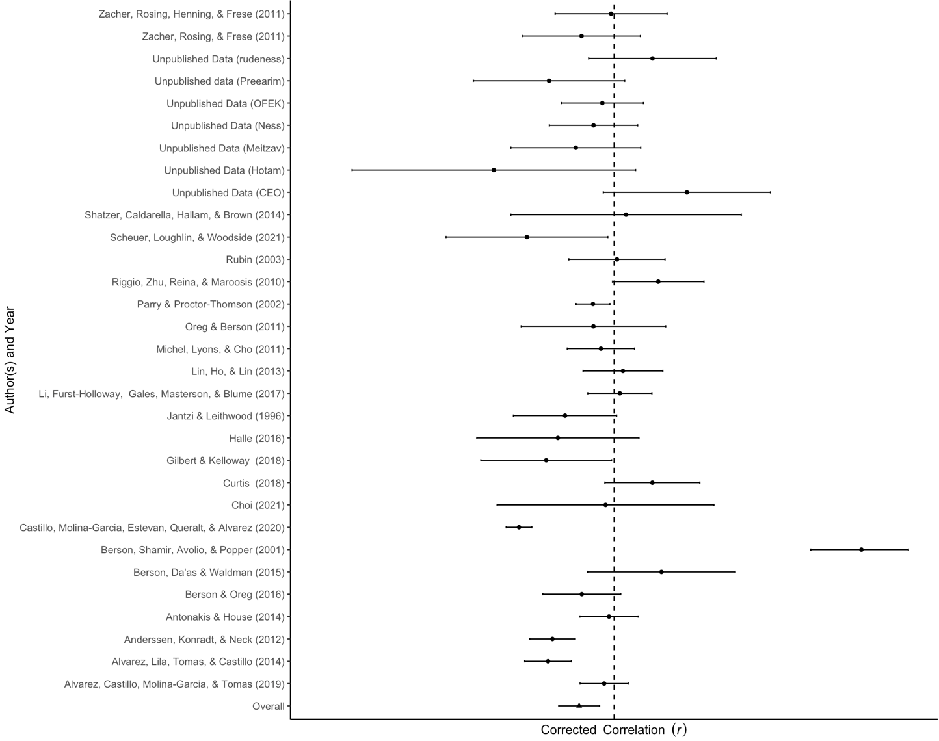

Note: Each row shows the effect size estimate from each study included in the intellectual stimulation sample (corrected correlations r). The horizontal black line represents the width of the confidence interval. When the line does not touch the effect size 0, which is represented by the black vertical dotted line, it suggests that the effect is statistically significant.

Figure S1f

Forest Plot – Individual Consideration

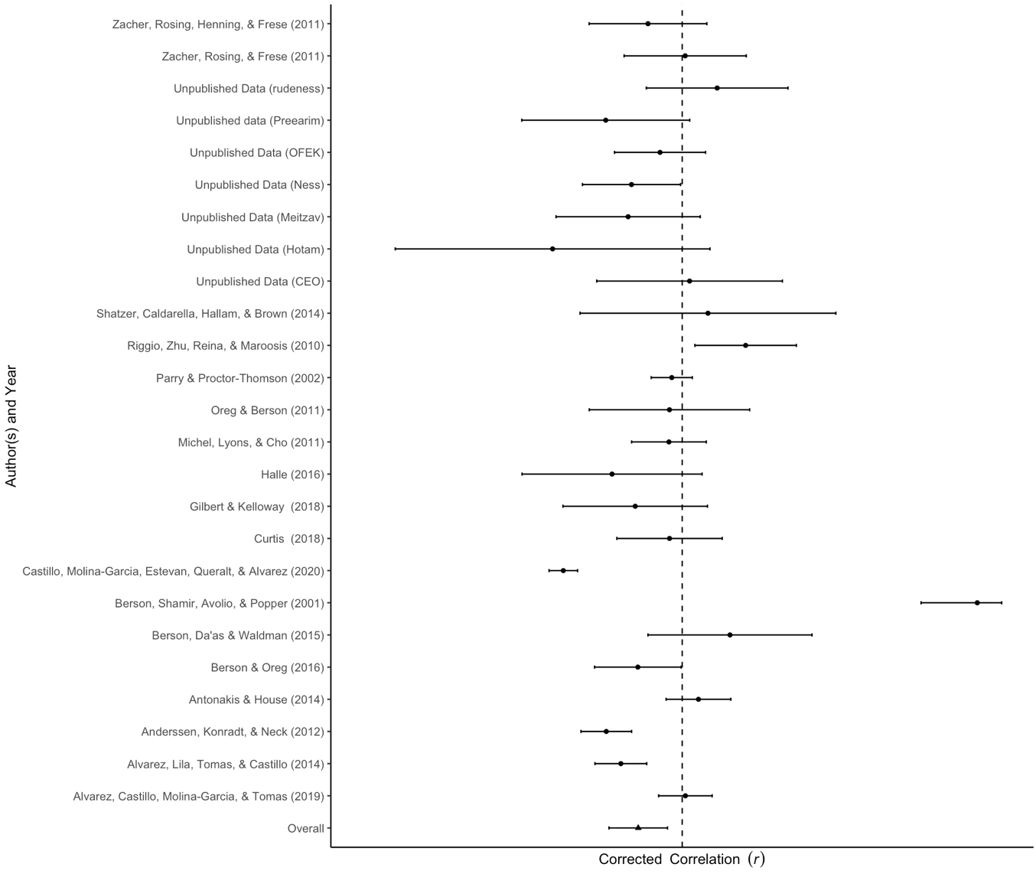
Note: Each row shows the effect size estimate from each study included in the individual consideration sample (corrected correlations r). The horizontal black line represents the width of the confidence interval. When the line does not touch the effect size 0, which is represented by the black vertical dotted line, it suggests that the effect is statistically significant.

Figure S2a

Forest Plot – Transactional Leadership
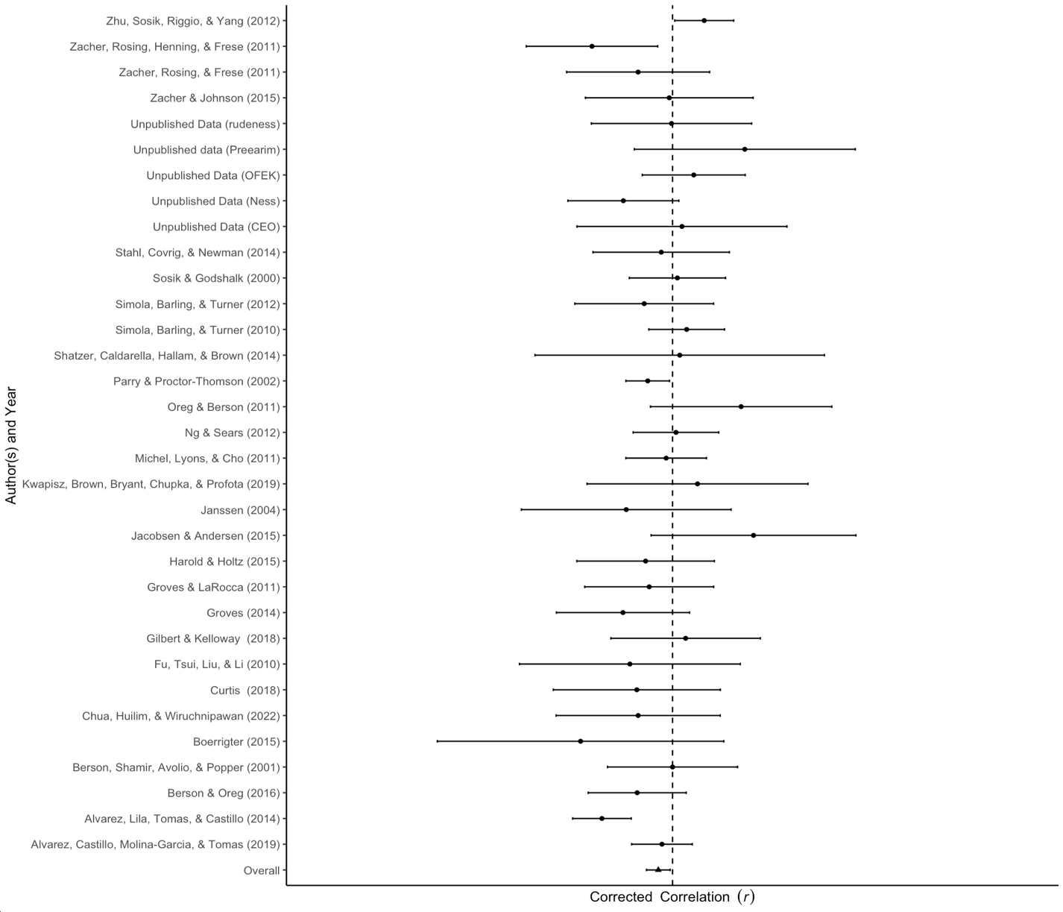
Note: Each row shows the effect size estimate from each study included in the transactional leadership sample (corrected correlations r). The horizontal black line represents the width of the confidence interval. When the line does not touch the effect size 0, which is represented by the black vertical dotted line, it suggests that the effect is statistically significant.

Figure S2b

Forest Plot – Contingent Reward
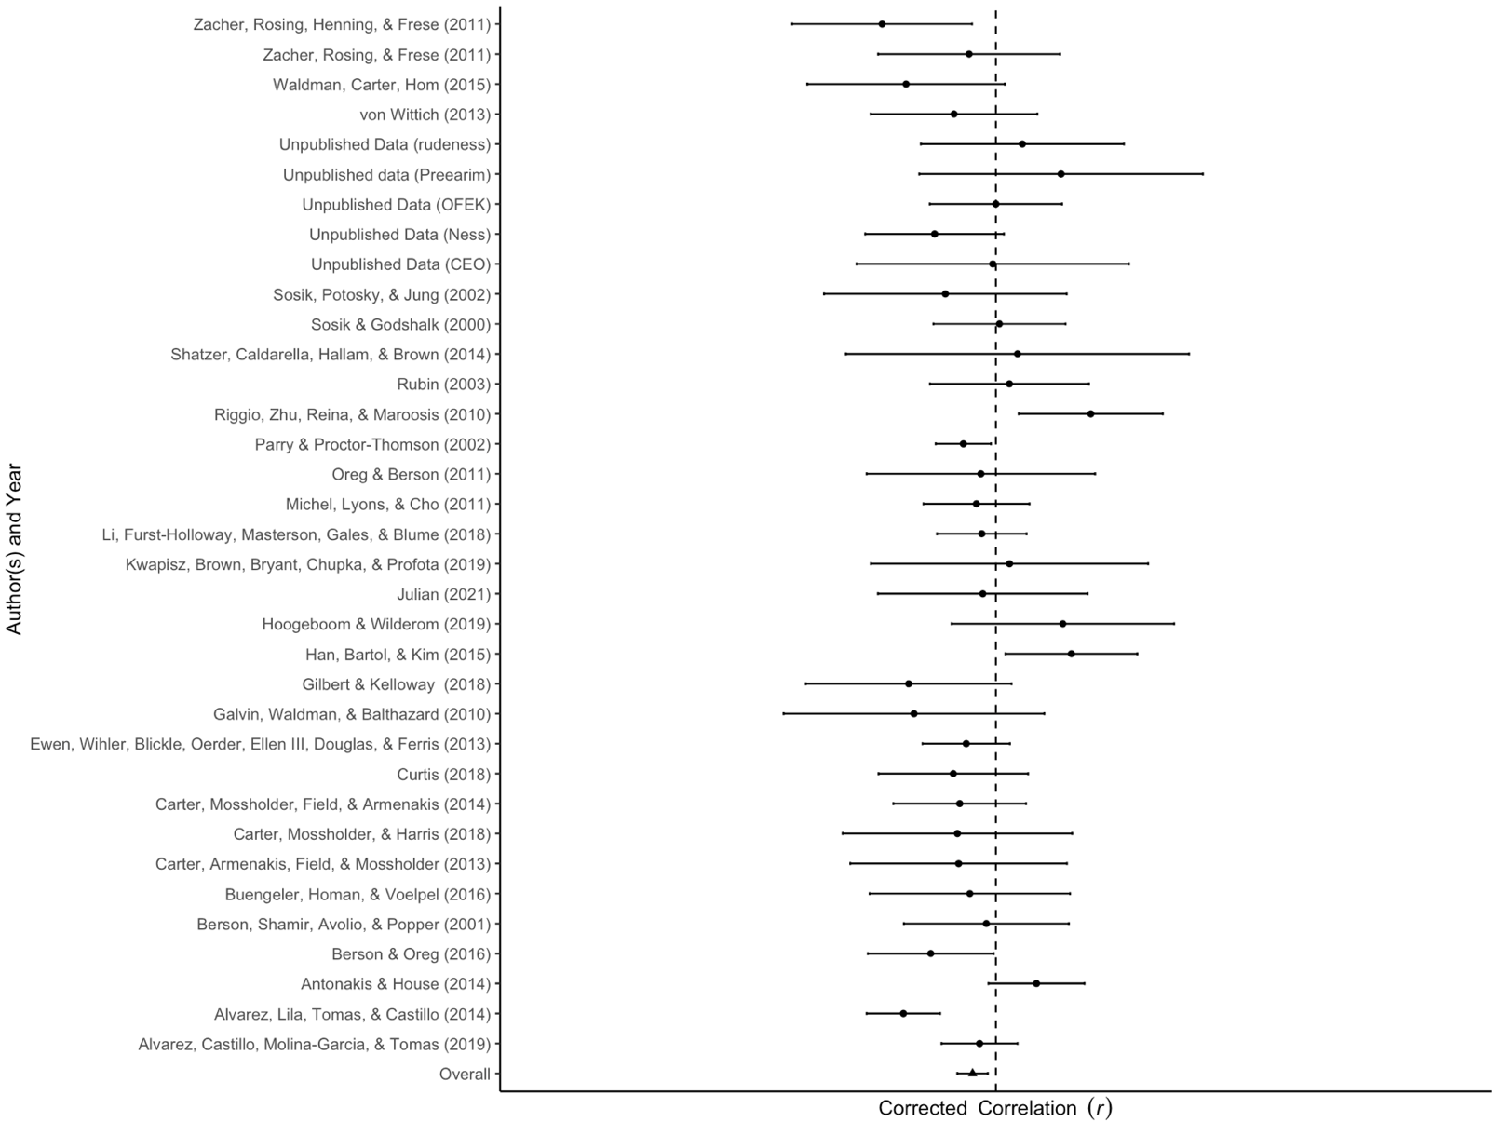
Note: Each row shows the effect size estimate from each study included in the contingent reward sample (corrected correlations r). The horizontal black line represents the width of the confidence interval. When the line does not touch the effect size 0, which is represented by the black vertical dotted line, it suggests that the effect is statistically significant.

Figure S3

Forest Plot – Passive Leadership
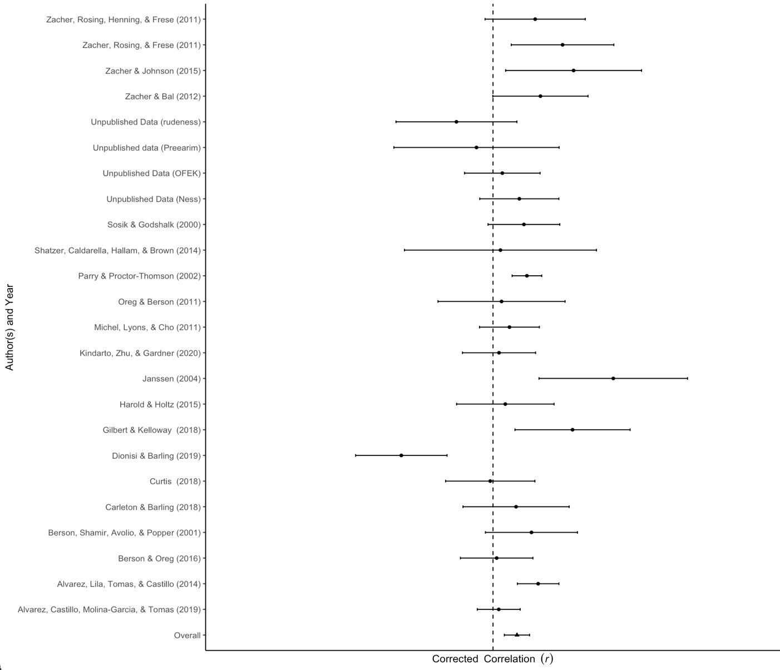
Note: Each row shows the effect size estimate from each study included in the passive leadership sample (corrected correlations r). The horizontal black line represents the width of the confidence interval. When the line does not touch the effect size 0, which is represented by the black vertical dotted line, it suggests that the effect is statistically significant.

Figure S4a

Forest Plot – Management-by-exception-passive

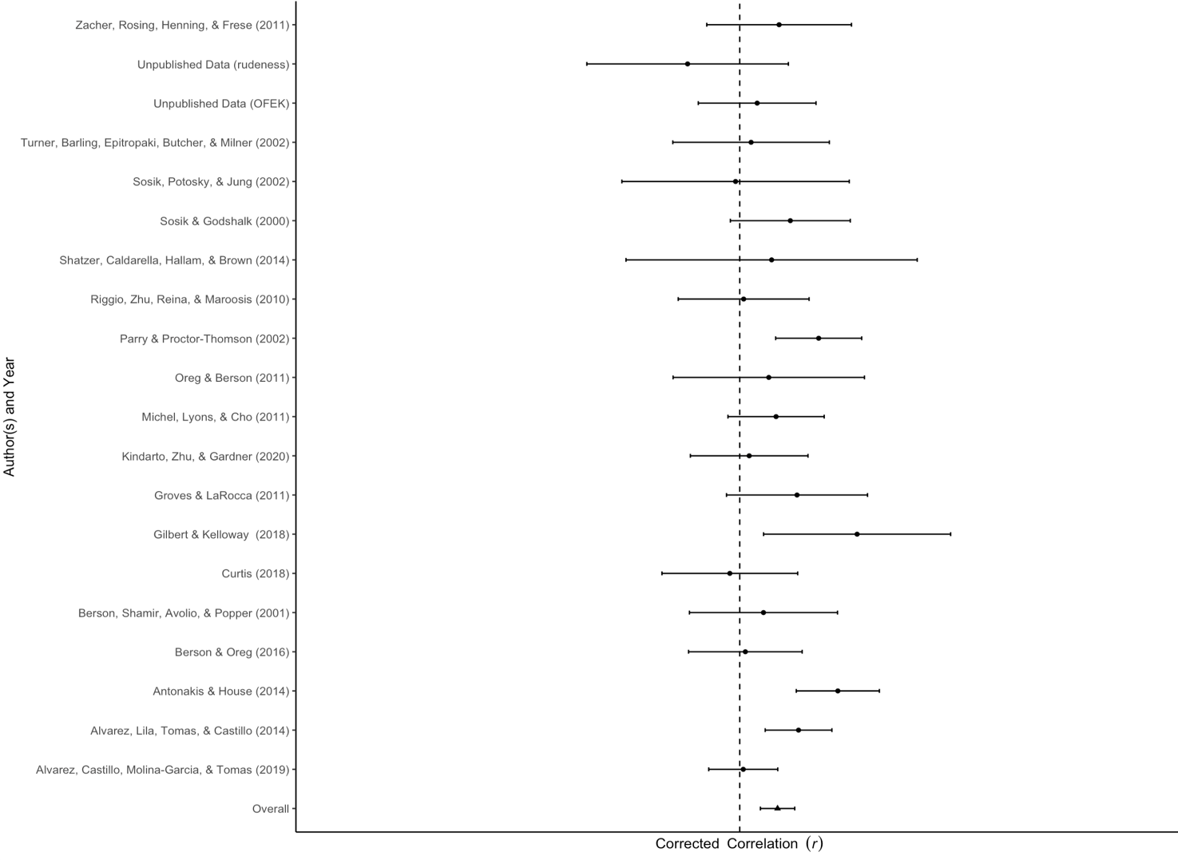

Note: Each row shows the effect size estimate from each study included in the management-by-exception-passive sample (corrected correlations r). The horizontal black line represents the width of the confidence interval. When the line does not touch the effect size 0, which is represented by the black vertical dotted line, it suggests that the effect is statistically significant.

Figure S4b

Forest Plot – Laissez-faire
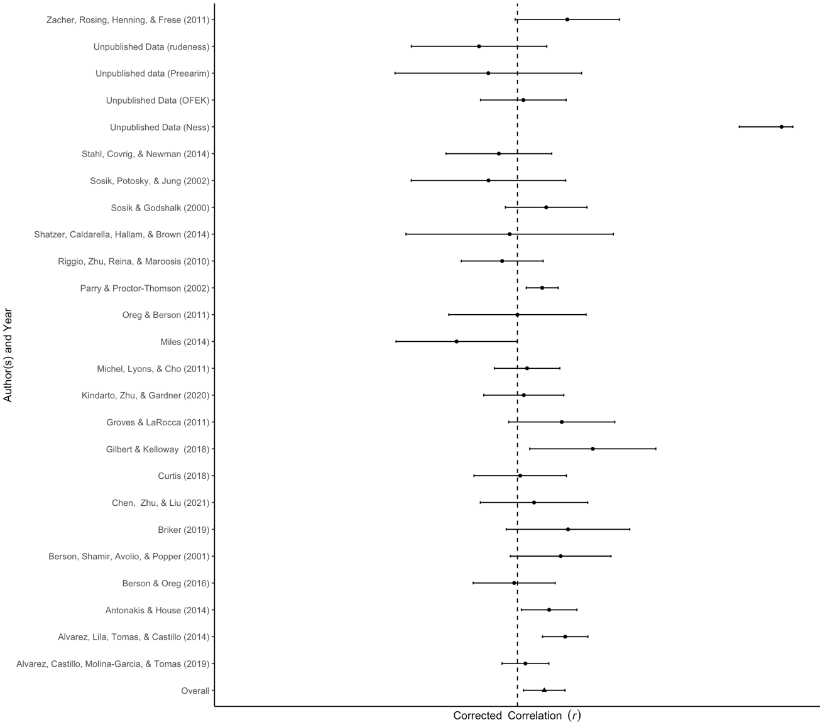
Note: Each row shows the effect size estimate from each study included in the laissez-faire sample (corrected correlations r). The horizontal black line represents the width of the confidence interval. When the line does not touch the effect size 0, which is represented by the black vertical dotted line, it suggests that the effect is statistically significant.

Figure S5a

Passive Leadership: The Moderating Effect of Uncertainty Avoidance

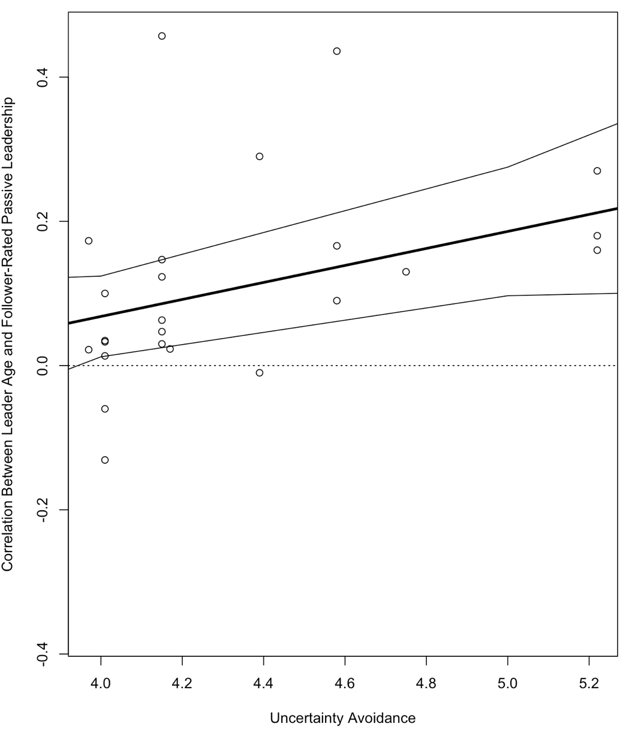

Figure S5b

Management-by-exception-passive: The Moderating Effect of Uncertainty Avoidance

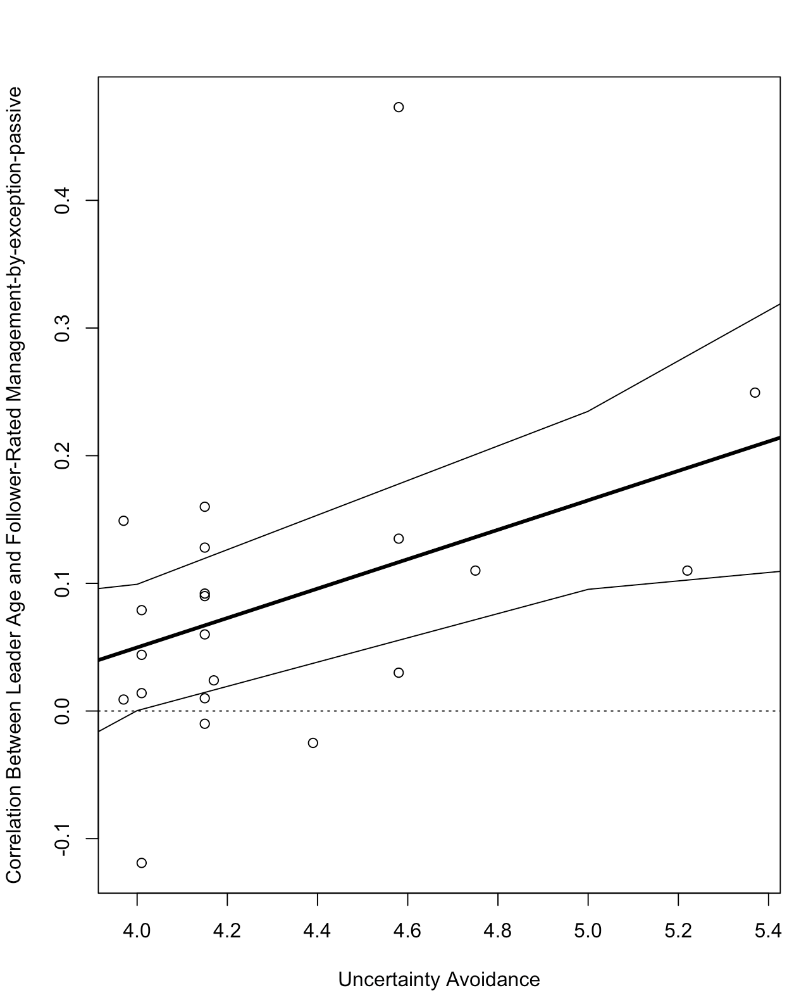
Figures S6a and S6b

- Idealized Attributes: The Moderating Effect of Power Distance
- Idealized Behaviors: The Moderating Effect of Uncertainty Avoidance

- 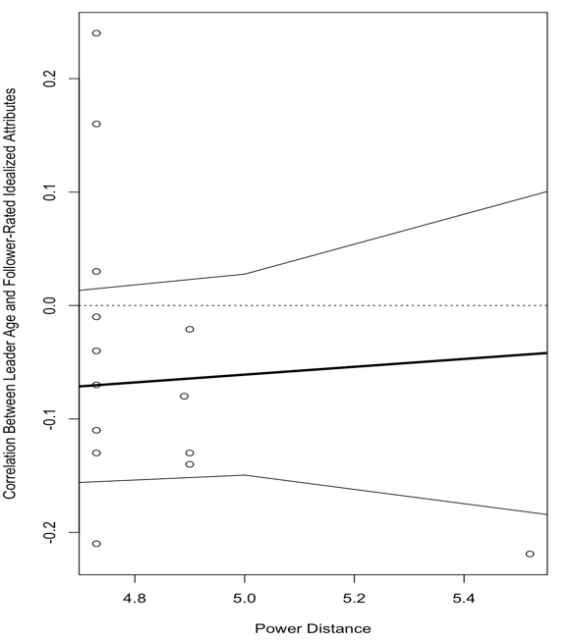b.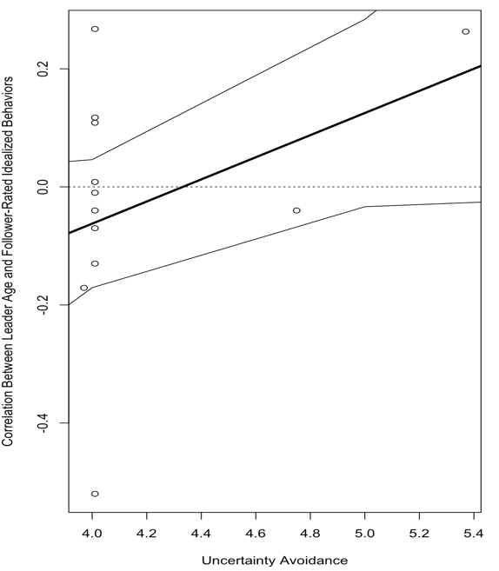
Appendix

Reference list of all studies included in the meta-analysis.
Álvarez, O., Castillo, I., Molina-García, V., & Tomás, I. (2019). Transformational Leadership,
Task-Involving Climate, and Their Implications in Male Junior Soccer Players: A Multilevel Approach. International Journal of Environmental Research and Public Health, 16, 1-11. https://doi.org/10.3390/ijerph16193649
Álvarez, O., Lila, M., Tomás, I., & Castillo, I. (2014). Transformational leadership in the local
police in Spain: A leader-follower distance approach. The Spanish Journal of Psychology, 17, 1-9. https://doi.org/10.1017/sjp.2014.44
Andressen, P., Konradt, U., & Neck, C. P. (2012). The relation between self-leadership and
transformational leadership: Competing models and the moderating role of virtuality. Journal of Leadership & Organizational Studies, 19, 68-82. https://doi.org/10.1177/1548051811425047
Anthony, E. L. (2012). What about the leader? An examination of the antecedents and
consequences of leader empowerment(Doctoral dissertation, Purdue University).
Antonakis, J., Fenley, M., & Liechti, S. (2011). Can charisma be taught? Tests of two
interventions. Academy of Management Learning & Education, 10(3), 374-396. https://doi.org/10.5465/amle.2010.0012
Antonakis, J., & House, R. J. (2014). Instrumental leadership: Measurement and extension of
transformational–transactional leadership theory. The Leadership Quarterly, 25, 746-771. https://doi.org/10.1016/j.leaqua.2014.04.005
Arnold, K.A., Connelly, C.E., Gellatly, I.R. Walsh, M.M., & Withey, M.J. (2017). Using a
pattern-oriented approach to study leaders: Implications for leader burnout and perceived role demands. Journal of Organizational Behavior, 38(7), 1038-1056. doi: 10.1002/job.2182.
Berson, Y., Da'as, R. A., & Waldman, D. A. (2015). How do leaders and their teams bring about organizational learning and outcomes? Personnel Psychology, 68, 79-108.
https://doi.org/10.1111/peps.12071
Berson, Y., & Oreg, S. (2016). The role of school principals in shaping children’s
values. Psychological Science, 27, 1539-1549. https://doi.org/10.1177/0956797616670147
Berson, Y., Shamir, B., Avolio, B. J., & Popper, M. (2001). The relationship between vision strength, leadership style, and context. The Leadership Quarterly, 12, 53-73.
https://doi.org/10.1016/S1048-9843(01)00064-9
Boerrigter, C. M. M. (2015). How leader's age is related to leader effectiveness: Through
leader's affective state and leadership behavior (Bachelor's thesis, University of Twente).
Boyer-Davis, S. L. (2014). Technostress in information technology managers: A quantitative
examination of the effect of transformational, transactional, or laissez-faire leadership style (Doctoral dissertation, Capella University).
Brands, R. A., Menges, J. I., & Kilduff, M. (2015). The leader-in-social-network schema:
Perceptions of network structure affect gendered attributions of charisma. Organization Science, 26, 1210-1225. https://doi.org/10.1287/orsc.2015.0965
Breevaart, K., Bakker, A. B., Demerouti, E., Sleebos, D. M., & Maduro, V. (2014). Uncovering
the underlying relationship between transformational leaders and followers’ task performance. Journal of Personnel Psychology, 13, 194-203. https://doi.org/10.1027/1866-5888/a000118
Briker, R. (2019). Leadership needs time: the role of temporal cognitions for leadership
processes and outcomes (Doctoral Dissertation, Justus-Liebig-University Giessen).
Brown, M. E. (2002). Leading with values: The moderating influence of trust on values acceptance by employees. The Pennsylvania State University.
Buengeler, C., Homan, A. C., & Voelpel, S. C. (2016). The challenge of being a young
manager: The effects of contingent reward and participative leadership on team‐level turnover depend on leader age. Journal of Organizational Behavior, 37(8), 1224-1245. https://doi.org/10.1002/job.2101
Byrne, A., Dionisi, A. M., Barling, J., Akers, A., Robertson, J., Lys, R., ... & Dupré, K. (2014).
The depleted leader: The influence of leaders' diminished psychological resources on leadership behaviors. The Leadership Quarterly, 25, 344-357. https://doi.org/10.1016/j.leaqua.2013.09.003
Cardenas, C. C. (2015). Exploring the relationship between locus of control and leadership
styles among college students. Our Lady of the Lake University.
Carleton, E. L., & Barling, J. (2018). Adult attention deficit hyperactivity disorder symptoms
and passive leadership: The mediating role of daytime sleepiness. Stress and Health, 34(5), 663-673. https://doi.org/10.1002/smi.2833
Carleton, E. L., Barling, J., & Trivisonno, M. (2018). Leaders’ trait mindfulness and transformational leadership: The mediating roles of leaders’ positive affect and leadership self-efficacy. Canadian Journal of Behavioural Science / Revue canadienne des sciences du comportement, 50(3), 185–194. https://doi.org/10.1037/cbs0000103
Carter, M. Z., Armenakis, A. A., Feild, H. S., & Mossholder, K. W. (2013). Transformational leadership, relationship quality, and employee performance during continuous incremental organizational change. Journal of Organizational Behavior, 34, 942-958.
https://doi.org/10.1002/job.1824
Carter, M. Z., Mossholder, K. W., Feild, H. S., & Armenakis, A. A. (2014). Transformational
leadership, interactional justice, and organizational citizenship behavior: The effects of racial and gender dissimilarity between supervisors and subordinates. Group & Organization Management, 39, 691-719. https://doi.org/10.1177/1059601114551605
Carter, M. Z., Mossholder, K. W., & Harris, J. N. (2018). Congruence effects of contingent
reward leadership intended and experienced on team effectiveness: The mediating role of distributive justice climate. Journal of Occupational and Organizational Psychology, 91(3), 465-485. https://doi.org/10.1111/joop.12210
Castillo, I., Molina-García, J., Estevan, I., Queralt, A., & Álvarez, O. (2020). Transformational
Teaching in Physical Education and Students’ Leisure-Time Physical Activity: The Mediating Role of Learning Climate, Passion and Self-Determined Motivation. International Journal of Environmental Research and Public Health, 17, 1-16; doi:10.3390/ijerph17134844
Caza, A., Caza, B. B., & Posner, B. Z. (2021). Transformational leadership across cultures: Follower perception and satisfaction. Administrative Sciences, 11(1), 32. https://doi.org/10.3390/admsci11010032
Charbonnier-Voirin, A., El Akremi, A., & Vandenberghe, C. (2010). A multilevel model of transformational leadership and adaptive performance and the moderating role of climate for innovation. Group & Organization Management, 35, 699-726.
https://doi.org/10.1177%2F1059601110390833
Chaturvedi, S., Arvey, R. D., Zhang, Z., & Christoforou, P. T. (2011). Genetic underpinnings of
transformational leadership: The mediating role of dispositional hope. Journal of Leadership & Organizational Studies, 18(4), 469-479. https://doi.org/10.1177/1548051811404891
Chen, X., Zhu, Z., & Liu, J. (2021). Does a trusted leader always behave better? The
relationship between leader feeling trusted by employees and benevolent and laissez-faire leadership behaviors. Journal of Business Ethics, 170, 615-634. https://doi.org/10.1007/s10551-019-04390-7
Choi, J. Y. (2021). The Two Faces of Narcissistic Leaders: An Examination of the Roles of
Narcissistic Admiration and Rivalry in Understanding When and How Leader Narcissism Relates to Leadership Effectiveness. Drexel University.
Chua, R. Y., Lim, J. H., & Wiruchnipawan, W. (2022). Unlocking the creativity potential of
dialectical thinking: field investigations of the comparative effects of transformational and transactional leadership styles. The Journal of Creative Behavior, 56(2), 258-273. https://doi.org/10.1002/jocb.528
Curtis, G. (2018). Connecting influence tactics with full-range leadership styles. Leadership &
Organization Development Journal, 39, 2-13. https://doi.org/10.1108/LODJ-09-2016-0221
Davidson, B. (2014). Examining the relationship between non-cognitive skills and leadership:
The influence of hope and grit on transformational leadership behavior (Doctoral dissertation, University of Kansas).
de Koster, R. B., Stam, D., & Balk, B. M. (2011). Accidents happen: The influence of safety-
specific transformational leadership, safety consciousness, and hazard reducing systems on warehouse accidents. Journal of Operations Management, 29, 753-765. https://doi.org/10.1016/j.jom.2011.06.005
de Vries, R. E. (2012). Personality predictors of leadership styles and the self–other agreement
problem. The Leadership Quarterly, 23(5), 809-821. https://doi.org/10.1016/j.leaqua.2012.03.002
Den Hartog, D. N., & Boon, C. (2018). Great Minds Think Alike? Congruence in Leader and
Follower Organizational Identification and Perceptions of Leader Charisma. In Leadership Now: Reflections on the Legacy of Boas Shamir(Vol. 9, pp. 177-194). Emerald Publishing Limited.
Diebig, M., Poethke, U., & Rowold, J. (2017). Leader strain and follower burnout: Exploring
the role of transformational leadership behaviour. German Journal of Human Resource Management, 31(4), 329-348. https://doi.org/10.1177/2397002217721077
Dionisi, A. M., & Barling, J. (2019). What happens at home does not stay at home: The role of
family and romantic partner conflict in destructive leadership. Stress and Health, 35(3), 304-317. https://doi.org/10.1002/smi.2858
Douglas, C. (2012). The moderating role of leader and follower sex in dyads on the leadership
behavior–leader effectiveness relationships. The Leadership Quarterly, 23(1), 163-175. https://doi.org/10.1016/j.leaqua.2011.11.013
Duan, J., Li, C., Xu, Y., & Wu, C. H. (2017). Transformational leadership and employee voice
behavior: A Pygmalion mechanism. Journal of Organizational Behavior, 38(5), 650-670. https://doi.org/10.1002/job.2157
Duan, J., Ren, X., Liu, Z., & Riggio, R. E. (2022). Connecting the dots: How parental and
current socioeconomic status shape individuals’ transformational leadership. Journal of Business Research, 150, 51-58. https://doi.org/10.1016/j.jbusres.2022.06.014
Egri, C. P., & Herman, S. (2000). Leadership in the North American environmental sector:
Values, leadership styles, and contexts of environmental leaders and their organizations. Academy of Management journal, 43(4), 571-604. https://doi.org/10.5465/1556356
Eldor, L. (2021). Leading by doing: Does leading by example impact productivity and service
quality?. Academy of Management Journal, 64(2), 458-481. https://doi.org/10.5465/amj.2018.0706
Esquivel, E. P. (2019). A Study of the Relationship between a Leader's Socioeconomic Origin in
Their Childhood Years and Their Transformational Leadership Style as an Adult. Our Lady of the Lake University.
Ewen, C., Wihler, A., Blickle, G., Oerder, K., Ellen III, B. P., Douglas, C., & Ferris, G. R.
(2013). Further specification of the leader political skill–leadership effectiveness relationships: Transformational and transactional leader behavior as mediators. The Leadership Quarterly, 24, 516-533. https://doi.org/10.1016/j.leaqua.2013.03.006
Felfe, J., & Schyns, B. (2004). Is similarity in leadership related to organizational outcomes? The
case of transformational leadership. Journal of Leadership & Organizational Studies, 10(4), 92-102. https://doi.org/10.1177/107179190401000407
Flanigan, R. L., Bishop, J. L., Brachle, B. J., & Winn, B. A. (2017). Leadership and Small Firm
Performance: The Moderating Effects of Demographic Characteristics. Creighton Journal of Interdisciplinary Leadership, 3(1), 2-19.
Føllesdal, H., & Hagtvet, K. (2013). Does emotional intelligence as ability predict
transformational leadership? A multilevel approach. The Leadership Quarterly, 24(5), 747-762. https://doi.org/10.1016/j.leaqua.2013.07.004
Fu, P. P., Tsui, A. S., Liu, J., & Li, L. (2010). Pursuit of whose happiness? Executive leaders'
transformational behaviors and personal values. Administrative Science Quarterly, 55(2), 222-254. https://doi.org/10.2189/asqu.2010.55.2.222
Galvin, B. M., Waldman, D. A., & Balthazard, P. (2010). Visionary communication qualities as
mediators of the relationship between narcissism and attributions of leader charisma. Personnel Psychology, 63, 509-537. https://doi.org/10.1111/j.1744-6570.2010.01179.x
Geibel, H. V., & Otto, K. (2023). Commitment is the key: a moderated mediation model linking
leaders’ resources, work engagement, and transformational leadership behavior. Psychological reports, 126(4), 1977-2002. https://doi.org/10.1177/00332941221074256
Gilbert, S. L. (2015). Motivation for transformational leadership in two organizations.
Gilbert, S., & Kelloway, E. K. (2018). Self-determined leader motivation and follower
perceptions of leadership. Leadership & Organization Development Journal, 39(5), 608-619. https://doi.org/10.1108/LODJ-09-2017-0262
Godshalk, V. M., & Sosik, J. J. (2000). Does mentor-protégé agreement on mentor leadership
behavior influence the quality of a mentoring relationship?. Group & Organization Management, 25(3), 291-317. https://doi.org/10.1177/1059601100253005
Grant, A. M. (2012). Leading with meaning: Beneficiary contact, prosocial impact, and the
performance effects of transformational leadership. Academy of Management Journal, 55, 458-476. https://doi.org/10.5465/amj.2010.0588
Greiman, B. C., & Addington, L. S. (2008). Youth leadership development self-efficacy: An
exploratory study involving a new construct. Journal of Leadership Education, 7(1), 1-23. https://education.biu.ac.il/sites/education/files/shared/Youth%20Leadership%20Development%20Self-Efficacy.pdf
Groves, K. S. (2014). Examining leader–follower congruence of social responsibility values in
transformational leadership. Journal of Leadership & Organizational Studies, 21, 227-243. https://doi.org/10.1177/1548051813498420
Groves, K. S., & LaRocca, M. A. (2011). An empirical study of leader ethical values,
transformational and transactional leadership, and follower attitudes toward corporate social responsibility. Journal of Business Ethics, 103, 511-528. https://doi.org/10.1007/s10551-011-0877-y
Gumusluoglu, L., & Ilsev, A. (2009). Transformational leadership, creativity, and
organizational innovation. Journal of Business Research, 62, 461-473. https://doi.org/10.1016/j.jbusres.2007.07.032
Hackett, R. D., Wang, A. C., Chen, Z., Cheng, B. S., & Farh, J. L. (2018). Transformational
leadership and organisational citizenship behaviour: A moderated mediation model of leader‐member‐exchange and subordinates' gender. Applied Psychology, 67(4), 617-644. https://doi.org/10.1111/apps.12146
Halle, Y. (2016). Influence of leader and follower behavior on employee voice, team task
responsibility, and team effectiveness (Master's thesis, University of Twente).
Han, J. H., Bartol, K. M., & Kim, S. (2015). Tightening up the performance–pay linkage: Roles
of contingent reward leadership and profit-sharing in the cross-level influence of individual pay-for-performance. Journal of Applied Psychology, 100(2), 417–430. https://doi.org/10.1037/a0038282
Harold, C. M., & Holtz, B. C. (2015). The effects of passive leadership on workplace
incivility. Journal of Organizational Behavior, 36, 16-38. https://doi.org/10.1002/job.1926
Hinduan, Z. R., Wilson‐Evered, E., Moss, S., & Scannell, E. (2009). Leadership, work outcomes
and openness to change following an Indonesian bank merger. Asia Pacific Journal of Human Resources, 47(1), 59-78. https://doi.org/10.1177/1038411108099290
Hoogeboom, M. A., & Wilderom, C. P. (2019). Advancing the transformational–transactional
model of effective leadership: Integrating two classic leadership models with a video‐based method. Journal of Leadership Studies, 13(2), 23-46. https://doi.org/10.1002/jls.21655
Hu, J., Wang, Z., Liden, R. C., & Sun, J. (2012). The influence of leader core self-evaluation on follower reports of transformational leadership. The Leadership Quarterly, 23, 860-868.
https://doi.org/10.1016/j.leaqua.2012.05.004
Hur, Y., van den Berg, P. T., & Wilderom, C. P. (2011). Transformational leadership as a
mediator between emotional intelligence and team outcomes. The Leadership Quarterly, 22, 591-603. https://doi.org/10.1016/j.leaqua.2011.05.002
Ishikawa, J. (2012). Transformational leadership and gatekeeping leadership: The roles of norm
for maintaining consensus and shared leadership in team performance. Asia Pacific Journal of Management, 29, 265-283. https://doi.org/10.1007/s10490-012-9282-z
Jacobsen, C. B., & Andersen, B. L. (2015). Is leadership in the eye of the beholder? A study
of intended and perceived leadership practices and organizational performance. Public Administration Review, 75(6), 829-841. https://doi.org/10.1111/puar.12380
Janssen, L. T. (2004). Leadership characteristics of hospital CEOs: Factors that influence
leadership style. Drake University.
Jantzi, D., & Leithwood, K. (1996). Toward an explanation of variation in teachers'
perceptions of transformational school leadership. Educational Administration Quarterly, 32(4), 512-538. https://doi.org/10.1177/0013161X9603200404
Jin, S., Seo, M. G., & Shapiro, D. L. (2016). Do happy leaders lead better? Affective and
attitudinal antecedents of transformational leadership. The Leadership Quarterly, 27(1), 64-84. https://doi.org/10.1016/j.leaqua.2015.09.002
Julian, A. (2021). Not to be taken out of context: The development and validation of a
contextualized measure of leader personality. Retrieved from: https://prism.ucalgary.ca/server/api/core/bitstreams/f0c4a116-b50d-4d71-9134-7930ea5706ee/content
Kearney, E. (2008). Age differences between leader and followers as a moderator of the relationship between transformational leadership and team performance. Journal of Occupational and Organizational Psychology, 81, 803-811. https://doi.org/10.1348/096317907X256717
Khan, A. N., & Khan, N. A. (2022). The nexuses between transformational leadership and
employee green organisational citizenship behaviour: Role of environmental attitude and green dedication. Business Strategy and the Environment, 31(3), 921-933. https://doi.org/10.1002/bse.2926
Kim, T. Y., Liden, R. C., Kim, S. P., & Lee, D. R. (2015). The interplay between follower core
self-evaluation and transformational leadership: Effects on employee outcomes. Journal of Business and Psychology, 30, 345-355. https://doi.org/10.1007/s10869-014-9364-7
Kindarto, A., Zhu, Y. Q., & Gardner, D. G. (2020). Full range leadership styles and government
IT team performance: The critical roles of follower and team competence. Public Performance & Management Review, 43(4), 889-917. https://doi.org/10.1080/15309576.2020.1730198
Kirkman, B. L., Chen, G., Farh, J. L., Chen, Z. X., & Lowe, K. B. (2009). Individual power distance orientation and follower reactions to transformational leaders: A cross-level, cross-cultural examination. Academy of Management Journal, 52, 744-764.
https://doi.org/10.5465/amj.2009.43669971
Kopperud, K. H., Martinsen, Ø., & Humborstad, S. I. W. (2014). Engaging leaders in the eyes
of the beholder: On the relationship between transformational leadership, work engagement, service climate, and self–other agreement. Journal of Leadership & Organizational Studies, 21(1), 29-42. https://doi.org/10.1177/1548051813475666
Kwapisz, A., Brown, F. W., Bryant, S., Chupka, R., & Profota, T. (2019). The relative
importance of transformational leadership and contingent reward on satisfaction with supervision in nonprofit and for-profit organizations. Journal of International & Interdisciplinary Business Research, 6(1), 42-63. Doi 10.58809/QESL3759
Lanaj, K., Gabriel, A. S., & Jennings, R. E. (2023). The importance of leader recovery for
leader identity and behavior. Journal of Applied Psychology, 108(10), 1717–1736. https://doi.org/10.1037/apl0001092
Lange, S., Bormann, K. C., & Rowold, J. (2018). Mindful leadership: Mindfulness as a new
antecedent of destructive and transformational leadership behavior. Gruppe. Interaktion. Organisation. Zeitschrift für Angewandte Organisationspsychologie (GIO), 49(2), 139–147. https://doi.org/10.1007/s11612-018-0413-y
Li, J., Furst-Holloway, S., Gales, L., Masterson, S. S., & Blume, B. D. (2017). Not all
transformational leadership behaviors are equal: The impact of followers’ identification with leader and modernity on taking charge. Journal of Leadership & Organizational Studies, 24(3), 318-334. https://doi.org/10.1177/1548051816683894
Li, J., Furst-Holloway, S., Masterson, S. S., Gales, L. M., & Blume, B. D. (2018). Leader-
member exchange and leader identification: Comparison and integration. Journal of Managerial Psychology, 33(2), 122-141. https://doi.org/10.1108/JMP-06-2017-0220
Lin, L. H., Ho, Y. L., & Lin, W. H. E. (2013). Confucian and Taoist work values: An
exploratory study of the Chinese transformational leadership behavior. Journal of Business Ethics, 113, 91-103. https://doi.org/10.1007/s10551-012-1284-8
Longenecker, P. D. (2006). Evaluating transformational leadership skills of hospice
executives. American Journal of Hospice and Palliative Medicine®, 23(3), 205-211. https://doi.org/10.1177/1049909106289082
Lowe, C. (2016). Measuring the self-perceived transformational leadership skills of school
counselors: A comparison across settings (Doctoral dissertation, University of South Carolina).
Mao, J. Y., Chiang, J. T. J., Zhang, Y., & Gao, M. (2017). Humor as a relationship lubricant:
The implications of leader humor on transformational leadership perceptions and team performance. Journal of Leadership & Organizational Studies, 24(4), 494-506. https://doi.org/10.1177/1548051817707518
Martin, J. (2015). Transformational and transactional leadership: An exploration of gender,
experience, and institution type. portal: Libraries and the Academy, 15(2), 331-351. 10.1353/pla.2015.0015
Mayberry, C. L. (2011). Social entrepreneurs: The role of entrepreneurial orientation and
leadership style in non-profit organizations (Doctoral dissertation, University of British Columbia).
Mayr, M. L., & Boenigk, S. (2019). Knowledge Management in Public and Nonprofit
Organizations. Zeitschrift für öffentliche und gemeinwirtschaftliche Unternehmen: ZögU/Journal for Public and Nonprofit Services, 42(H. 1/2), 155-175. https://www.jstor.org/stable/26864505
McEvoy, A. (2022). Overstressed and Understudied: An Examination of Stress and Workplace
Leaders (Doctoral dissertation, Carleton University).
Michel, J. W., Lyons, B. D., & Cho, J. (2011). Is the full-range model of leadership really a
full-range model of effective leader behavior? Journal of Leadership & Organizational Studies, 18, 493-507. https://doi.org/10.1177/1548051810377764
Miles, A. (2014). An examination of the relationship between perceived leadership behaviors,
perceived team cohesion and team performance. (Doctoral Dissertation, Kennesaw State University).
Moore, L. L. (2003). Leadership in the cooperative extension system: An examination of
leadership styles and skills of state directors and administrators. University of Florida.
Moshavi, D., Brown, F. W., & Dodd, N. G. (2003). Leader self‐awareness and its relationship
to subordinate attitudes and performance. Leadership & Organization Development Journal, 24, 407-418. https://doi.org/10.1108/01437730310498622
Ng, E. S., & Sears, G. J. (2012). CEO leadership styles and the implementation of
organizational diversity practices: Moderating effects of social values and age. Journal of Business Ethics, 105, 41-52. https://doi.org/10.1007/s10551-011-0933-7
Oluwafemi, T. B., Mitchelmore, S., & Nikolopoulos, K. (2020). Leading innovation: Empirical
evidence for ambidextrous leadership from UK high-tech SMEs. Journal of Business Research, 119, 195-208. https://doi.org/10.1016/j.jbusres.2019.10.035
Onorato, M. (2013). Transformational leadership style in the educational sector: An empirical
study of corporate managers and educational leaders. Academy of Educational Leadership Journal, 17(1), 33-47. http://library.tcu.edu/PURL/EZproxy_link.asp?/login?url=https://www.proquest.com/scholarly-journals/transformational-leadership-style-educational/docview/1368593704/se-2
Oreg, S., & Berson, Y. (2011). Leadership and employees’ reactions to change: The role of
leaders’ personal attributes a transformational leadership style. Personnel
Psychology, 64, 627-659. https://doi.org/10.1111/j.1744-6570.2011.01221.x
Parry, K. W., & Proctor-Thomson, S. B. (2002). Perceived integrity of transformational leaders
in organisational settings. Journal of Business Ethics, 35, 75-96. https://doi.org/10.1023/A:1013077109223
Pastor, J. C., & Mayo, M. (2006). Transformational and transactional leadership: an examination
of managerial cognition among Spanish upper echelons. Instituto de Empresa Business School Working Paper No. WP06-13.
Patsko, S. M. (2016). Spirituality and leadership: The relationship between self-assessed
spirituality and transformational leadership in private school division heads. Our Lady of the Lake University.
Perez, E. (2023). An Exploration of the Leaders’ Perfectionism and the Leaders’ Leadership
Style (Doctoral dissertation, Our Lady of the Lake University).
Peterson, S. J., Galvin, B. M., & Lange, D. (2012). CEO servant leadership: Exploring executive
characteristics and firm performance. Personnel Psychology, 65(3), 565-596. https://doi.org/10.1111/j.1744-6570.2012.01253.x
Rahman, M. S., Ferdausy, S., & Bhattacharjee, S. (2014). Assessing the relationships among
transformational leadership, transactional leadership, job performance, and gender: an empirical study. ABAC Journal, 34(3).
Qian, S., Yuan, Q., Lim, V. K., Niu, W., & Liu, Z. (2020). Do job insecure leaders perform
less transformational leadership? The roles of emotional exhaustion and trait mindfulness. Journal of Leadership & Organizational Studies, 27(4), 376-388. https://doi.org/10.1177/1548051820938327
Qu, R., Janssen, O., & Shi, K. (2015). Transformational leadership and follower creativity: The
mediating role of follower relational identification and the moderating role of leader creativity expectations. The Leadership Quarterly, 26, 286-299. https://doi.org/10.1016/j.leaqua.2014.12.004
Riggio, R. E., Zhu, W., Reina, C., & Maroosis, J. A. (2010). Virtue-based measurement of
ethical leadership: The Leadership Virtues Questionnaire. Consulting Psychology Journal: Practice and Research, 62, 235-250. https://doi.org/10.1037/a0022286
Robertson, J. L. (2014). Greening organizations: The roles of leadership and organizational
citizenship behaviors. (Doctoral Dissertation, Queen's University).
Robertson, J. L. (2018). The nature, measurement and nomological network of environmentally
specific transformational leadership. Journal of Business Ethics, 151(4), 961-975. https://doi.org/10.1007/s10551-017-3569-4
Robertson, J. L., & Barling, J. (2013). Greening organizations through leaders' influence on
employees' pro‐environmental behaviors. Journal of Organizational Behavior, 34, 176-194. https://doi.org/10.1002/job.1820
Rubin, R. S. (2003). Paddling upstream in leadership research: Exploring antecedents of
transformational leadership behavior. (Doctoral Dissertation, Saint Louis University).
Rubin, R. S., Munz, D. C., & Bommer, W. H. (2005). Leading from within: The effects of
emotion recognition and personality on transformational leadership behavior. Academy of Management Journal, 48, 845-858. https://doi.org/10.5465/amj.2005.18803926
Scheuer, C. L., & Loughlin, C. (2021). Seizing the benefits of age diversity: could empowering
leadership be the answer?. Leadership & Organization Development Journal. 42 (3), 495-515. https://doi.org/10.1108/LODJ-12-2019-0516
Scheuer, C. L., Loughlin, C., & Woodside, A. G. (2021). Can You Always Catch More Flies
with Honey than with Vinegar? Applying an Asymmetric Approach to Transformational Leadership Research. Journal of Business and Psychology, 1-23. https://doi.org/10.1007/s10869-021-09737-4
Schuh, S. C., Zhang, X. A., Egold, N. W., Graf, M. M., Pandey, D., & van Dick, R. (2012).
Leader and follower organizational identification: The mediating role of leader behaviour and implications for follower OCB. Journal of Occupational and Organizational Psychology, 85(2), 421-432. https://doi.org/10.1111/j.2044-8325.2011.02044.x
Shala, A. (2021). Transformational Leadership: The Role of Leader's Formal Education and
Professional Training(Doctoral dissertation, James Madison University).
Shatzer, R. H., Caldarella, P., Hallam, P. R., & Brown, B. L. (2014). Comparing the effects of
instructional and transformational leadership on student achievement: Implications for practice. Educational Management Administration & Leadership, 42, 445-459. https://doi.org/10.1177/1741143213502192

Siangchokyoo, N. (2018). A Multi-Level Longitudinal Investigation of Transformational

Leadership Influence on Team Members Development in Engineering Project Teams. doi:10.25777/hdgq-3308
Simola, S. K., Barling, J., & Turner, N. (2010). Transformational leadership and leader moral
orientation: Contrasting an ethic of justice and an ethic of care. The Leadership Quarterly, 21, 179-188. https://doi.org/10.1016/j.leaqua.2009.10.013
Simola, S., Barling, J., & Turner, N. (2012). Transformational leadership and leaders’ mode of
care reasoning. Journal of Business Ethics, 108, 229-237. https://doi.org/10.1007/s10551-011-1080-x
Song, X., Shi, K., & Zhou, W. (2022). Mechanisms of Organizational Cultural Tightness on
Work Engagement during the COVID-19 Pandemic: The Moderating Role of Transformational Leadership. Behavioral Sciences, 13(1), 27. https://doi.org/10.3390/bs13010027
Sosik, J., Chun, J. U., Ete, Z., Cheong, M., Arenas, F., & Scherer, J. (2020). Maniac or Master?
Examining How Leader Self-Control of Affective Experiences Shapes Charismatic Leadership. Journal of Character and Leadership Development, 7(2), 111-134.
Sosik, J. J., & Godshalk, V. M. (2000). The role of gender in mentoring: Implications for
diversified and homogenous mentoring relationships. Journal of Vocational Behavior, 57(1), 102-122. https://doi.org/10.1006/jvbe.1999.1734
Sosik, J. J., Juzbasich, J., & Chun, J. U. (2011). Effects of moral reasoning and management
level on ratings of charismatic leadership, in-role and extra-role performance of managers: A multi-source examination. The Leadership Quarterly, 22(2), 434-450. https://doi.org/10.1016/j.leaqua.2011.02.015
Sosik, J. J., Potosky, D., & Jung, D. I. (2002). Adaptive self-regulation: Meeting others'
expectations of leadership and performance. The Journal of Social Psychology, 142, 211-232. https://doi.org/10.1080/00224540209603896
Sosik, J. J., Zhu, W., & Blair, A. L. (2011). Felt authenticity and demonstrating transformational
leadership in faith communities. Journal of Behavioral and Applied Management, 12(3), 179-199.
Spott, M. A. (2015). Are there differences between surgeons in all surgical specialties with
respect to the way they believe they lead? (Doctoral Dissertation, Our Lady of the Lake University).
Stahl, A., Covrig, D., & Newman, I. (2014). Understanding board leadership: Adventist
hospital board chair behaviors and effectiveness and organizational outcomes. Journal of Applied Christian Leadership, 8, 49-66. Available at: https://digitalcommons.andrews.edu/jacl/vol8/iss2/5
Turner, N., Barling, J., Epitropaki, O., Butcher, V., & Milner, C. (2002). Transformational
leadership and moral reasoning. Journal of Applied Psychology, 87, 304-311. doi:10.1037/0021-9010.87.2.304
Van Solinge, S. W. (2014). Are older leaders less transformational? The role of age for transformational leadership from the perspective of socioemotional selectivity theory (Doctoral Dissertation, University of Groningen).
Van Thielen, T., Vanderstraeten, A., Decramer, A., & Audenaert, M. (2019). Using performance
management to manage teams: as a useful tool or an ambush. In XI International Workshop on HRM. http://hdl.handle.net/1854/LU-8608594
Van Woerkom, M., & De Reuver, R. S. (2009). Predicting excellent management performance in
an intercultural context: A study of the influence of multicultural personality on transformational leadership and performance. The International Journal of Human Resource Management, 20(10), 2013-2029. https://doi.org/10.1080/09585190903175589
Versteegh, J. J. A. (2015). The influence of arousal during transactional and transformational
leadership on leader effectiveness: exploratory organizational neuroscience research into the use of skin conductance in leadership research (Master's thesis, University of Twente).
Villarreal, S. (2016). A study of Early College High School students' leadership styles and career
readiness. Our Lady of the Lake University.
von Wittich, D. (2013). Three essays on leader individual differences and effectiveness (Doctoral Dissertation, Université de Lausanne, Faculté des hautes études commerciales).
Wadei, K. A., Lu, C., & Wu, W. (2021). Unpacking the chain mediation process between
transformational leadership and knowledge worker creative performance: Evidence from China. Chinese Management Studies. https://doi.org/10.1108/CMS-03-2020-0118
Wagner, D. N. (2010). Leadership education reconsidered: Examining self-perceived leadership
styles and motivation sources among undergraduate leaders (Doctoral dissertation, Bowling Green State University).
Waldman, D. A., Carter, M. Z., & Hom, P. W. (2015). A multilevel investigation of leadership
and turnover behavior. Journal of Management, 41, 1724-1744. https://doi.org/10.1177/0149206312460679
Waldman, D. A., Galvin, B. M., & Walumbwa, F. O. (2013). The development of motivation to
lead and leader role identity. Journal of Leadership & Organizational Studies, 20(2), 156-168.
https://doi.org/10.1177/1548051812457416
Wang, G., & Hackett, R. D. (2016). Conceptualization and measurement of virtuous leadership:
Doing well by doing good. Journal of Business Ethics, 137, 321-345. https://doi.org/10.1007/s10551-015-2560-1
Wang, X. H. F., & Howell, J. M. (2012). A multilevel study of transformational leadership,
identification, and follower outcomes. The Leadership Quarterly, 23, 775-790. https://doi.org/10.1016/j.leaqua.2012.02.001
Wang, Y. S., & Huang, T. C. (2009). The relationship of transformational leadership with group
cohesiveness and emotional intelligence. Social Behavior and Personality: an International Journal, 37, 379-392. https://doi.org/10.2224/sbp.2009.37.3.379
Williams, D. J. (2014). The relationship between span of control and leadership style of nurse
leaders. Indiana Wesleyan University.
Williams, C. L. (2015). Essential elements for women's promotion: A comparison of leadership
and communicator styles among women in upper and middle management positions (Doctoral dissertation, Capella University).
Wofford, J. C., Whittington, J. L., & Goodwin, V. L. (2001). Follower motive patterns as situational moderators for transformational leadership effectiveness. Journal of Managerial Issues, 13, 196-211. https://doi.org/172.222.217.153
Wolfram, H. J., & Mohr, G. (2009). Transformational leadership, team goal fulfillment, and
follower work satisfaction: The moderating effects of deep-level similarity in leadership dyads. Journal of Leadership & Organizational Studies, 15, 260-274. https://doi.org/10.1177/1548051808326595
Wu, W. L., & Lee, Y. C. (2020). Do work engagement and transformational leadership facilitate
knowledge sharing? A perspective of conservation of resources theory. International journal of environmental research and public health, 17(7), 2615.
Zacher, H., & Bal, P. M. (2012). Professor age and research assistant ratings of passive-avoidant
and proactive leadership: The role of age-related work concerns and age stereotypes. Studies in Higher Education, 37(7), 875-896. https://doi.org/10.1080/03075079.2011.557829
Zacher, H., & Johnson, E. (2015). Leadership and creativity in higher education. Studies in
Higher Education, 40, 1210-1225. https://doi.org/10.1080/03075079.2014.881340
Zacher, H., Rosing, K., & Frese, M. (2011a). Age and leadership: The moderating role of
legacy beliefs. The Leadership Quarterly, 22, 43-50. https://doi.org/10.1016/j.leaqua.2010.12.006
Zacher, H., Rosing, K., Henning, T., & Frese, M. (2011b). Establishing the next generation at
work: Leader generativity as a moderator of the relationships between leader age, leader-
member exchange, and leadership success. Psychology and Aging, 26, 241-252. https://doi.org/10.1037/a0021429
Zhang, X. A., Cao, Q., & Tjosvold, D. (2011). Linking transformational leadership and team
performance: A conflict management approach. Journal of Management Studies, 48, 1586-1611. https://doi.org/10.1111/j.1467-6486.2010.00974.x
Zhang, S., Sun, W., Ji, H., & Jia, J. (2021). The antecedents and outcomes of transformational
leadership: leader's self-transcendent value, follower's environmental commitment and behavior. Leadership & Organization Development Journal, 42(7), 1037-1052. https://doi.org/10.1108/LODJ-10-2020-0471
Zhao, X., Fu, N., & Liang, X. (2023). Whose customer orientation? Exploring the relationships
between leaders, team customer orientation climate and customer satisfaction. Journal of Service Theory and Practice. https://doi.org/10.1108/JSTP-09-2022-0210
Zhu, W., Sosik, J. J., Riggio, R. E., & Yang, B. (2012). Relationships between transformational
and active transactional leadership and followers' organizational identification: The role of psychological empowerment. Journal of Behavioral and Applied Management, 13, 186-212.

